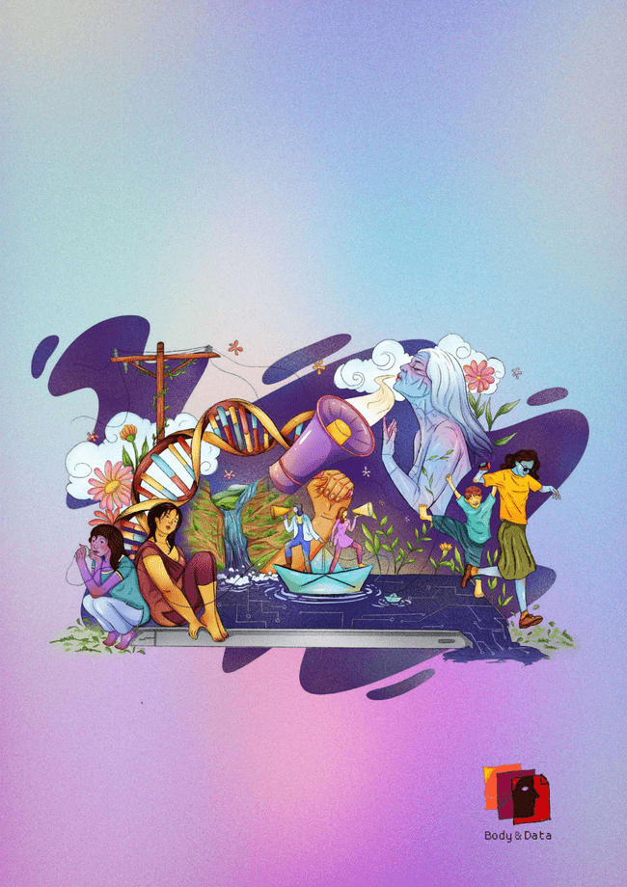**Body & Data Annual Report**

* **2024**

"Safe, Just and Accessible Digital Space for All"

1

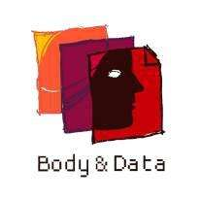

Author

Anisha (Aneekarma)

Editor

Monika

Contributors

Nuva Rai, Dovan Rai

Layout Design

Shrijit Rajbhandari

Illustration

Mrigaja Bajracharya

Published by

Body & Data

With Support from

Vision for Change

© 2025 Body & Data. All rights reserved.

**@bodyanddata**



Facebook Instagram Bluesky X

Contact:

info@bodyanddata.org

bodyanddata.org

Phone number & address details

**V**

**TABLE OF CONTENTS**

Page 1

1. Note of Grati-tude (By Executive Director)

Page 5

Our Strategic

Objectives

Pages 12-13

Capacity Building

Page 14

Advocacy &

Campaign

4.1 16 Days of Activism

Against Gender-Based

Violence

Page 2-3



Our Year at a Glance

Pages 6-7

CPCL: Legal Fellow-ship in Action

1.1 Reading Circles

1.2 Decriminalizing Digital Expression: Legal Fellow-ship for Online Sexual Rights in Nepal

1.3 Fellowship Graduation

Pages 15-16

Cross-Movement Collaborations

5.1 Women in Governance

5.2 Global Voices

5.3 Additional

Engagements

Page 4

Who Are We

* Mission
* Vision
* Goals

Pages 8-11

Knowledge

Generation

2.1 Media Monitoring

2.2 Community Radio

2.3 NID Research

2.4 SATH Partnership

2.5 Blogs

Page 17

Our Partners

Page 18

Looking forward to 2025!



**A NOTE OF GRATITUDE**

Dovan Rai, Executive Director

As we conclude the year 2024, there’s so much to be thankful for.

I am deeply honored to join Body & Data at this pivotal moment of transition. I have long admired Body & Data — for the boldness of its work, the strength of its convictions, and the supportive community it has nurtured over these years.

Since stepping into this role, I am even more heartened to witness the strong foundations that have been built. We are committed to honoring this foundation — and to building upon it.

We extend our deepest gratitude to those who have created and sustained this work, to the team members who continued with us through this transition, and to the new members who have joined our journey.

We are also deeply thankful to our Board of Directors for their unwavering guidance and robust support.

To our feminist community and our donor organi-zations — your generosity, understanding, and openness during this time of change has meant a lot to us. Your solidarity has reaffirmed for us the vital importance of nurturing a feminist ecosystem rooted in collective care, resource sharing and mutual trust.

As we look ahead to the new year and the years to come, amidst sweeping technological advance-ments, rapid geopolitical shifts and mounting complexities, we are reminded more than ever of the enduring power of organizing and the impor-tance of communities that uplift and sustain one another. Thank you to our friends, partners, allies, and well-wishers who continue to walk alongside us. We look forward to deepening our work and continuing to our mission of creating accessible, safe and just digital spaces for all.

1

**OUR YEAR AT A**

**GLANCE**

Founded in 2017, Body & Data embraced 2024 as a year of renewal. With the conclusion of our Co-founder Executive Director’s term in 2023, we stepped into a new phase of leadership, bringing fresh energy and direction to our work!

In 2024, we welcomed new leadership and team members who strengthened our vision and impact. Bharat Man Shrestha joined as Board chair, Navina Gyawali as a board member, and Dovan Rai as the Interim Director of Strategy in June. In November, Dovan transitioned into the role of Executive Director, leading Body & Data into its next chapter. Additionally, Monika joined as the Programs Director, bringing valuable expertise and dedication to our initiatives.We also relocated from Bhaktapur to Ekantakuna, Lalitpur, a more accessible location.

Along with our organizational changes, we continued our CPCL program (Countering Protec-tionist and Criminalized Legal framework in

Nepal around online sexual expression of women and queer individuals), deepened our engage-ment in policy advocacy, and laid a feminist foundation for 2025. Collaborating with experts and resource persons from different back-grounds, we strengthened our multidisciplinary approach to digital rights and justice.

One of the key milestones of 2024 was the graduation of the first cohort of the Body & Data’s Legal Fellows through the CPCL Program. Our fellows engaged deeply with communities, critically examined policies, and produced meaningful work that will contribute to shaping the discourse around online sexual expression and its policy landscape in Nepal.

2024 was a year of reflection, resilience, and transformation. We laid the groundwork for an even more powerful future. As we move forward, we remain committed to promoting a safer, more inclusive, and just digital space for all!

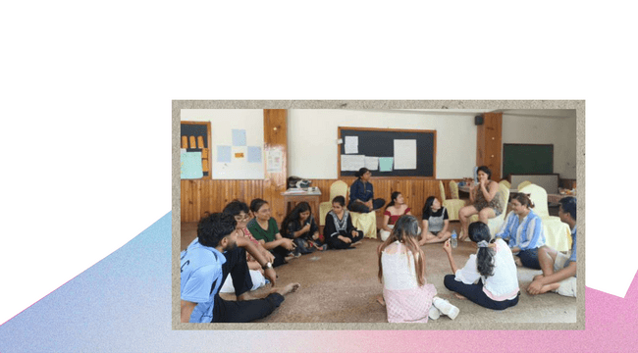

2

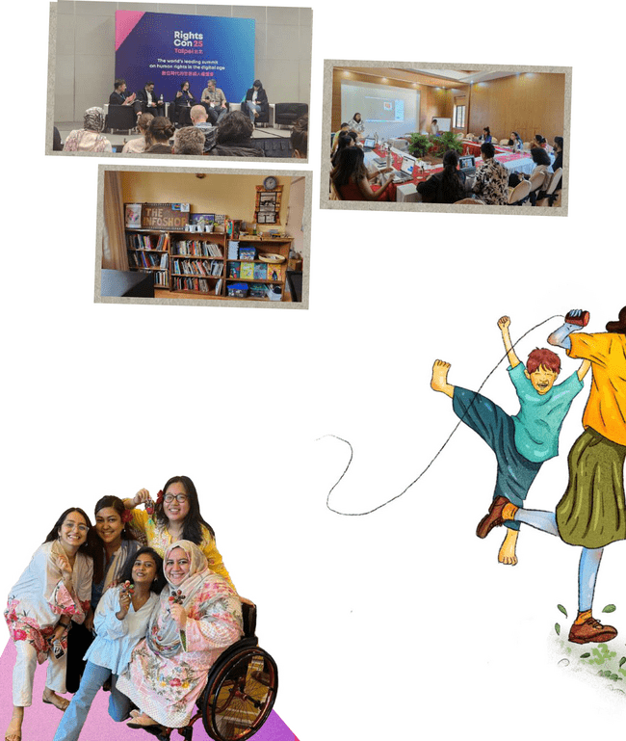

3

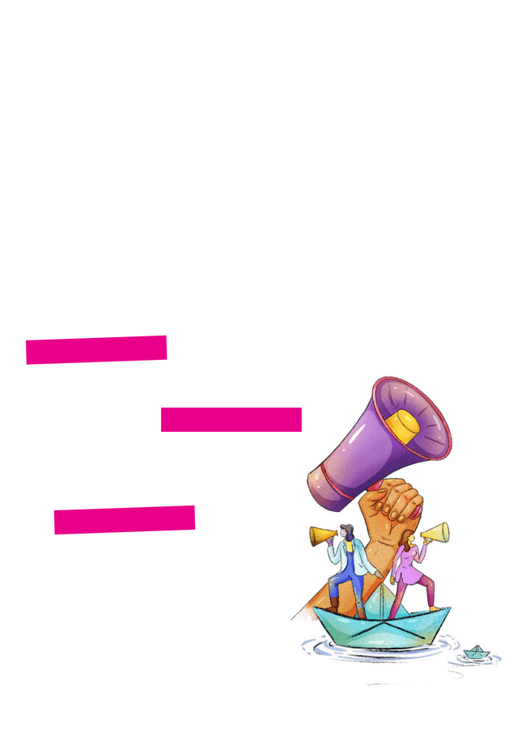**WHO ARE WE**

Established in 2017, Body & Data works to enhance understanding and access to information on digital rights among women, queer people and marginalized groups where they are able to exercise their rights in a safe and just digital space.

We work towards the vision of accessible, safe and just digital space for all, through cross movement building, facilitation for access to information, knowledge building and dissemination of digital rights in the context of Nepal.

**Vision**

Accessible, Safe and Just digital space for all.

**Mission**

We advocate, campaign and adopt suitable strategies to ensure accessible, just and safe digital space for marginalized people.

**Goals**

1. Enhanced understanding and access to information on digital rights among women, queer people, marginalized communities and stakeholders.
   1. Women, queer people and marginal-ized groups are able to exercise their rights in a safe and just digital space.

4

**OUR STRATEGIC**

**OBJECTIVES**

**Knowledge Generation:**

Knowledge building and dissemination on digital rights in the context of Nepal through consultations, research, workshops/capacity building and outreach.

**Capacity Building:**

Facilitation for access to information and knowledge, and learning of women, queer people and minority groups on digital rights through building space and outreach.

**Advocacy & Campaign:**

Cross movement building among relevant civil society movements through dialogue, advocacy and collaboration.

5

**CPCL PROGRAM: BODY & DATA LEGAL FELLOWSHIP IN ACTION!**

“CPCL: Countering Protectionist and Criminalized Legal Framework in Nepal Around Online Sexual Expression of Women and Queer Individuals”

2024 was a landmark year for Body & Data as we launched and successfully completed our first legal fellowship. Throughout the time span of 7 months in 2023-2024, we engaged in a diverse range of activities aimed at strengthening digital rights advocacy and challenging protectionist and criminalization measures that censor online sexual expression.

Through the course of the fellowship, our fellows actively participated in workshops, FGDs, reading circles, and community engagement initiatives, enhancing critical knowledge on digital rights, online safety, and legal frameworks. These

sessions provided a space for in-depth discus-sions, knowledge-sharing, and skill-building, allowing fellows to critically analyze and address issues related to online sexual expression. Beyond training, our fellows immersed them-selves in community work– conducting outreach activities, raising awareness, and initiating conversations on digital rights within their respective networks. Their dedication and com-mitment led to the creation of meaningful projects, including research initiatives, advocacy materials, and legal resources that contribute to the broader fight for digital rights and online freedom of expression. Out of 12 fellows, 10 graduated. This first cohort set a strong founda-tion for Body & Data’s fellowship programs, and we look forward to continuing our fellowship programs centering marginalized communities, and amplifying voices that challenge oppressive digital policies in Nepal and beyond.

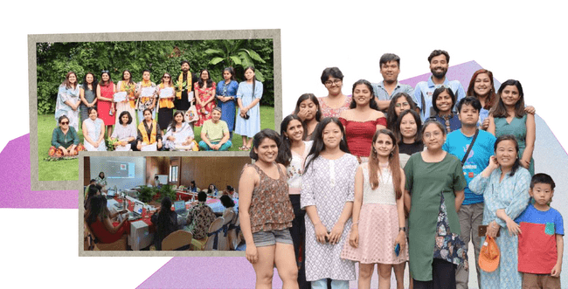

6

Let’s take a closer look at all the activities we did with our fellows in 2024!

**1.1 Reading Circles**

Body & Data organized monthly virtual reading circles with the fellows. These sessions created a collaborative platform to discuss critical issues such as sex workers’ rights online, the sexual expression of women and queer persons with disabilities, the TikTok ban, the criminalization of online sexual expression, and Nepal’s legal and social standing on these matters. Fellows en-gaged with key readings, including “Beyond Access: Women and queer persons with disabili-ties expressing self and exploring sexuality online” and “महिलाको यौनिक अभिव्यक्तिको अर््थ”by Babita Rai, as well as analyzed newspaper articles comprehensively to deepen their understanding of these issues through a legal lens.

disproportionately affect marginalized groups in the Global South. Additionally, fellows were introduced to Public Interest Litigation (PIL) strat-egies, equipping them with the tools to challenge unjust laws and advocate for the decriminaliza-tion of online sexual expression.

One of the central themes of the workshop was intersectionality, exploring how multiple identi-ties; such as gender, caste, disability, and sexual-ity, shape individuals’ experiences online and how marginalized communities face compound-ed challenges.. The workshop featured expert resource persons from various fields, including international law, queer rights, sex workers’ rights, and disability rights, who provided valu-able insights and practical knowledge.

The reading circles enabled fellows to dig into the systemic barriers faced by marginalized communi-ties, particularly women, queer individuals, and sex workers, and to reflect on the broader implications of criminalization and policy gaps within Nepal.



**1.2 Decriminalizing Digital Expression: Legal Fellowship for Online Sexual Rights in Nepal**

A 4-day workshop focused on the criminalization and censorship of digital expression, particularly their impact on marginalized communities such as sex workers, queer individuals, and persons with disabilities. The workshop provided an opportunity to examine Digital Colonialism through a postcolonial critique of international law, specifically from a Nepali perspective, where fellows discussed how global legal frameworks

**1.3 Fellowship Graduation**

The first cohort of Body & Data Legal Fellows graduated in August this year, marking a signifi-cant milestone for the fellowship program. Over the course of seven months, the fellows worked diligently on projects that addressed various legal scenarios, particularly in relation to the protec-tionist and criminalized lens affecting marginal-ized communities. During the graduation ceremo-ny, the fellows presented their work among each other, sharing reflections and learnings from their 7-month journey. The occasion brought together board members, the fellows, and the Body & Data team. The graduation of this first cohort highlights the fellows capacity to drive meaningful legal and social change, as well as the growing influence of the Body and Data Legal Fellowship in shaping legal discourse around digital rights and online sexual expression in Nepal.

7

**KNOW OUR FELLOWS WORK!**

As part of the Body and Data Legal Fellowship, fellows produced a diverse range of content aimed at addressing digital rights and the decriminalization of online sexual expression. These included articles analyzing the impact of hate speech and harassment on individuals expressing their sexuality online, assessing privacy protections and legal frameworks, and critiquing the TikTok ban from a feminist perspective. Fellows also explored how consent can inform legislation related to online sexual expression and devel-oped educational materials addressing the rights and safety of marginalized communities in digital spaces.

In addition to written work, fellows created visual content to raise awareness of online sexual rights and provide legal insights into remedies for online harassment, cyberbullying, and non-consensu-al sharing of private content. Some projects focused on educating teenagers and individuals with disabilities about their bodies, sexuality, and sexual health, while also addressing the barriers these groups face in expressing themselves online.

These works will be disseminated in 2025 mainly through our CPCL Learning Portal, an open-access platform we developed to ensure these critical resources are accessible to anyone interested in learning more about these topics. The portal will serve as a hub for knowledge, legal insight, and advocacy tools around digital rights and online sexual expression. We are excited to launch the CPCL Learning Portal in 2025. You can access our learning portal at bodyanddata.org/cpcl_portal.

**12**

**Fellows**

**Participated**

**10**

**Fellows**

**Graduated**

**150+**

**Community**

**Members**

**Reached**

**8**

**Fellows Projects in the Process of Launching**

8

**KNOWLEDGE**

**GENERATION**

Knowledge generation is a core pillar of Body & Data’s work, enabling us to build a strong foundation for digital rights advocacy in Nepal. In 2024, we continued to produce, document, and disseminate critical knowledge that addresses the evolving challenges of online spaces, particularly for marginalized communities.

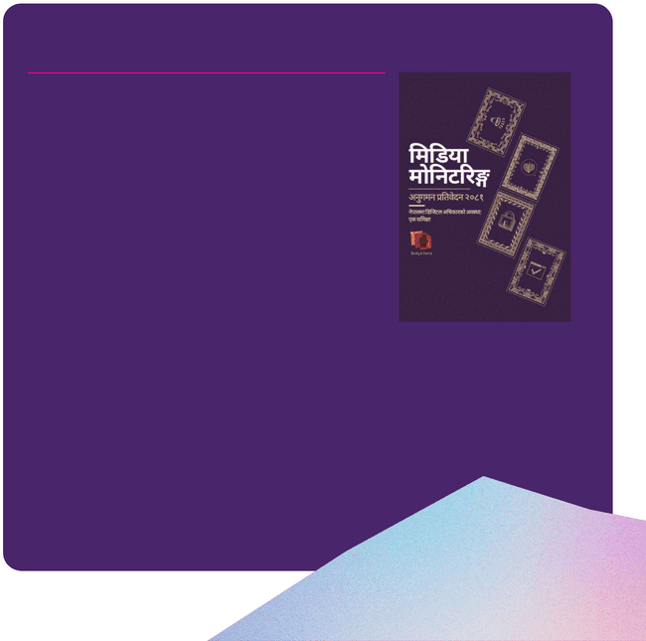

**2.1 Media Monitoring**

Since 2021, Body & Data has been monitoring and analyzing digital rights news through an intersectional feminist lens, producing quarterly and annual reports to inform and engage diverse audi-ences. In 2024, we expanded our reach by introducing English translations, allowing us to engage in regional and global dis-courses on digital rights, such as through the Digital Rights South Asia Forum. Supported by Astraea Lesbian Foundation for Justice, this initiative critically examined issues like online freedom of expression, sexual rights and privacy, technology-facilitated violence, and government-led digitization. By centering the per-spectives of women, queer individuals, and marginalized commu-nities, we highlighted gaps in discourse and shed light on the disproportionate impacts of digital policies and practices.

Our findings were shared through monthly social media updates, and an annual consolidated report. Beyond tracking trends and risks, this work has played a crucial role in shaping conversations around digital rights in Nepal. We will continue doing this work in 2025.

*You can access our 2024 Media Monitoring Report on our website at https://bodyanddata.org/MM*

9

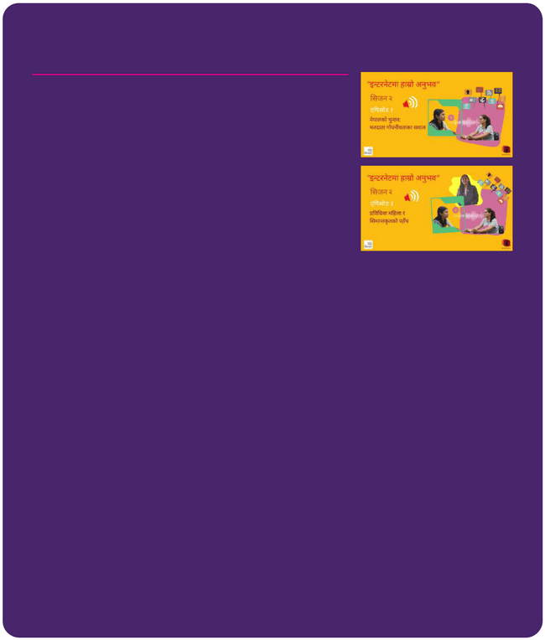

**2.2 Community Radio**

Building on the success of our first season, Body & Data launched the second season of its radio program in collaboration with Marsyangdi Radio, Lamjung, and 20 community radio stations across Gandaki Province. This initiative, which began in 2022, aimed to decentralize conversations around digital rights and human rights in the digital sphere, engaging communities beyond Kathmandu in these critical discussions.

Following the impactful first season in 2023, where we co-created and broadcast six episodes on key digital rights issues, the second season in 2024 continued to amplify these conversations. With new perspectives and a wider reach, the second season dived deeper into digital rights issues, bringing critical discussions to local communities in a way that was relevant and accessible. You can tune into all the episodes on our YouTube channel:

http://youtube.com/@bodydata3658.

Episode Title

* Voter Privacy Issues in Nepal
* The Right to Live Free from Violence
* Women's and Marginalized Groups' Access to Technology
* Privacy and Digital Surveillance
* Episode Digital Biometrics and Privacy
* A Comprehensive Overview of Episodes 1-5



10

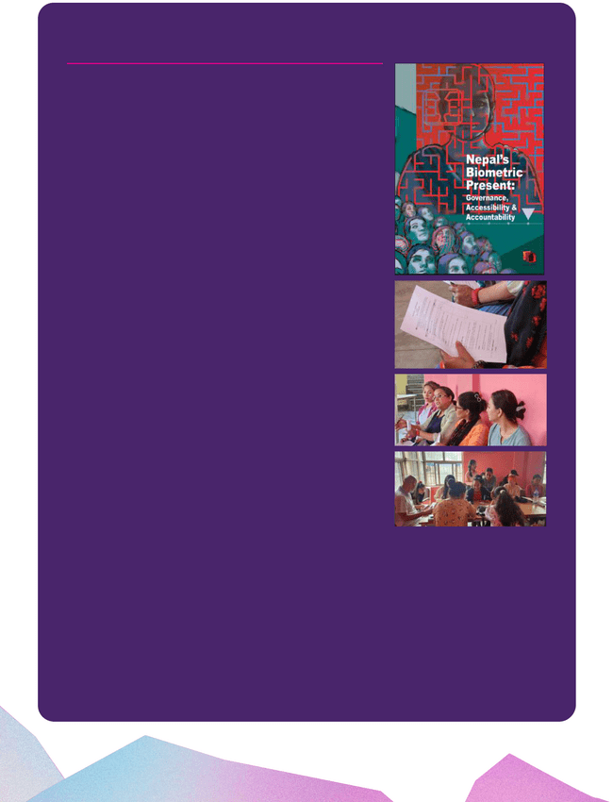

**2.3 National Identity Card (NID) Research**

The Government of Nepal has introduced the National Identity Card (NID) — a biometric system aimed at providing a comprehensive digital identification for its citizens. Under this initiative, each resi-dent is assigned a unique 10-digit identification number linked to a detailed record containing their biometric data — including a digital photograph, fingerprints, and iris scans — as well as key personal information such as name, address, and gender.

Between 2022 and 2023, Body & Data conducted research on NID across Kathmandu, Sarlahi, Khotang, Jhapa, and Panchthar, aiming to analyze both the state’s digitalization ambitions and the experiences and perspectives of local users. The study ex-plored the system’s implementation, accessibility, and the challenges faced by marginalized communities. Through our field visit, focus group discussions and interviews, we sought to understand how these technologies are being implemented by the government and how they are perceived across diverse populations and to assess potential risks related to privacy, data security, and digital exclusion.

This research builds upon our previous work, “Digitization of Identity in Nepal: Exports, Experiences, and Effect,” published in 2023.

We are now finalizing the new report, titled “Nepal’s Biometric Present: Governance, Access, and Accountability.” Following its publication, we plan to disseminate the findings through commu-nity events in the five districts where our research was conducted.

To ensure sustained engagement with this critical issue, we are also launching a series of complementary initiatives. We are developing an interactive web portal focused on the NID system and creating a Digital Safety Handbook on NID, which will be published in five ethnic languages alongside Nepali and English.

11

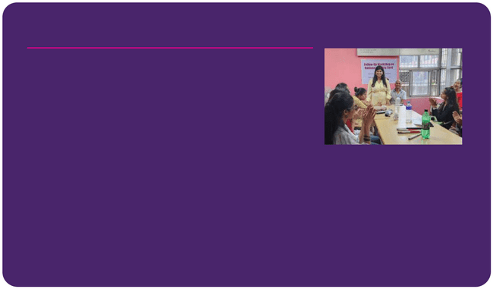**2.4 SATH Partnership**

A critical dialogue on the limitations of Nepal’s biometric National Identity (NID) card system was jointly hosted by Body & Data and Supportive Action Towards Humanity (SATH) in 2024. The one-day discussion program brought attention to the challenges faced by Persons with Disabilities (PWDs) in accessing and using biometric identification systems.

Drawing from global research and local experiences, the conversa-tion questioned the over-reliance on biometric data and emphasized the need for a rights-based, inclusive approach to national identity systems. The event also marked the beginning of an ongoing research collaboration between Body & Data and SATH, aiming to advocate for accessible and dignified identification processes that do not exclude or disadvantage marginalized communities.

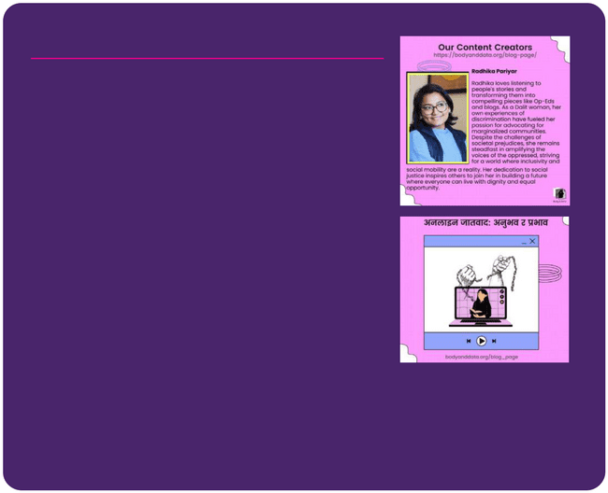

**2.5 Blog**

In the year 2024, Body & Data published an article that examines how technology and the internet reflect and reinforce existing social inequalities within our communities’ digital spaces.

The article, written by , explores the pervasive issue of caste-based discrimination in online spaces in Nepal, drawing from personal experiences and societal observations. The author recounts how their surname influenced interactions on social media, leading them to adopt an online identity concealing caste markers. Despite this, caste-based inquiries and discrimination persisted, including harassment, social exclusion, and implicit biases. The article highlights how online platforms, while offering freedom of expres-sion, also amplify casteism through offensive comments, microag-gressions, and exclusionary behaviors. It delves into the psycholog-ical impact of such discrimination, leading to self-doubt, anxiety, and social withdrawal. The piece argues that legal measures alone are insufficient to combat casteism and calls for educational reforms, awareness campaigns, and community engagement to dismantle caste-based biases. It emphasizes the importance of encouraging inclusive discussions and rejecting discriminatory social norms both online and offline.

You can access the blog here: https://bodyanddata.org/ online-caste-experience-impact/

12

**CAPACITY**

**BUILDING**

Since the inception of Body & Data, community engagement through capacity building has been at the heart of our work. We took a pause to reflect in 2024 due to our ongoing internal transitions. It was a necessary moment to look inward to under-stand our impact so far, identify what needs care, and think about how we want to move forward in more intentional and sustainable ways.

In 2025, we will build on what we’ve already created. We will evaluate two key programs, Feminist Tech Exchange (FTX) and Digital Story-telling Workshop (DSW), which have been central to equipping activists with digital rights knowledge and advocacy tools. The evaluations will build on the knowledge already created, making it more accessible and rooted in community needs.

Body&Data’s engagement through our Capacity Building programs has extended across diverse communities, including queer femi-nists, journalists, Dalit rights activists, and grassroots organizers. With intersectionality at the center of our work, we strive to create inclusive spaces that empower individuals to navigate digital rights issues and advocate for systemic change.

Looking back, we’ve welcomed over 175 people to our 10 workshops since 2017, and we’re excited to keep this momentum going in 2025!

13

**ADVOCACY &**

**CAMPAIGNS**

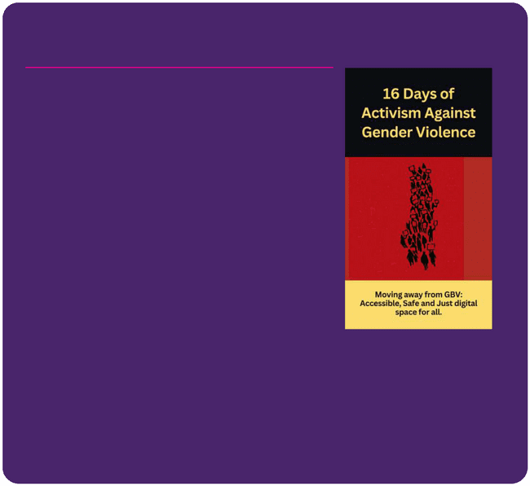

**4.1 16 Days of Activism Against Gender-Based Violence**

This year, as part of our advocacy efforts, Body & Data produced an educative video for the 16 Days of Activism Against Gender-Based Violence. The video explored the complexities of online gender-based violence (OGBV), shedding light on how digital spaces can be both harmful and empowering for women and gender-diverse individuals. We shared valuable insights on preventing OGBV, offering practical steps for individuals and communities to take action. Alongside this, we released a solidarity statement supporting the global movement against gender-based violence, reaffirming our commit-ment to creating safer digital spaces and raising awareness about the intersection of gender violence and technology.

During the same period, we collaborated with Sri Lanka’s Delete Nothing on a regional GBV campaign, amplifying the conversation around Technology Facilitated Gender Based Violence (TFGBV).

In addition, we partnered with Tech Global Institute, Access Now, and #KeepItOn to stand in solidarity with Bangladeshi students during the student-led protests. Together, we called for the restoration of internet access during student protests, reinforcing our collective commitment to defending digital rights and promoting justice across the region.



14

**CROSS-MOVEMENT COLLABORATIONS**



**5.1 Women in Governance**

Partnered with Asia Society India Centre to empower women in digital governance.

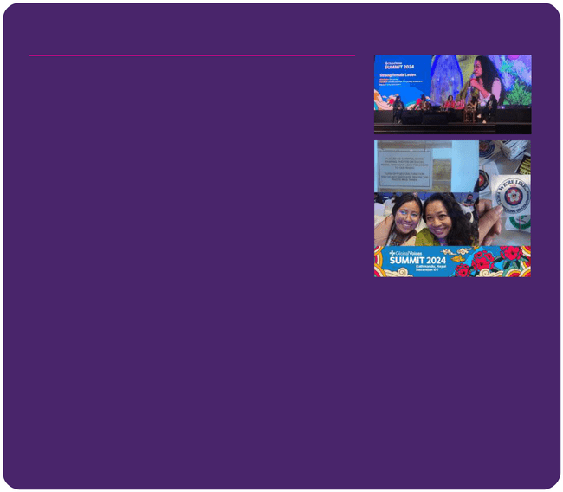

**5.2 Global Voices**

ED Dovan Rai spoke on ‘Strong Female Ledes’ at the Global Voices Summit (Dec 6-7), joined by Sr. Program Officer Nuva Rai.

Body & Data participated in the Global Voices Summit held in Kathmandu on December 6-7, 2024. This international gathering brought together writers, translators, human rights advocates, and technologists from around the globe to discuss digital media, knowledge, and activism. The summit featured discussions and training on a range of critical topics, including information ecosys-tems, content authenticity, data governance, digital security, the digital sovereignty of traditional knowledge, indigenous language digital activism, and multilingual media.

Dovan Rai from Body & Data joined the panel discussion “Strong Women Ledes,” which focused on the pivotal role of women in shaping the media industry, the persistent challenges they face, and ways to foster a more diverse and inclusive media landscape. Dovan spoke about the critical role digital infrastructure plays in supporting feminist movements and human rights defenders in Nepal and around the world. She shared Body & Data’s initiatives and commitment to creating accessible, safe, and just digital spaces for women and marginalized communities.



15



**5.3 Additional Engagements in 2024 included:**

* Digital Rights Festival, organized by Digital Freedom Coalition-Dovan Rai, panelist on the session: ‘Rights in the Machine: Challenges of AI Governance’, Dec 1
* Empowering Women in Politics: Combating Misinformation &

Hate Speech, organized by USAID and NDI, Barsa Rai, Admin and

Program Associate, participant

* South Asia Digital Rights Forum, Dovan, and Supriya (Board Member) participated in a 2 days workshop, June 29-30. We are continuing the engagement through signal group, monthly calls, white paper co-authorship.
* Provided consultation on digital transformation, organized by

UNDP- Dovan, Sep 19

* Provided consultation on The Governance of Digital Platforms Emerging Trends & Good Practices, organized by Freedom

Forum and UNESCO, Dovan, Sep 14

* Participated in the AWID Forum, Programs Director, Monika



16

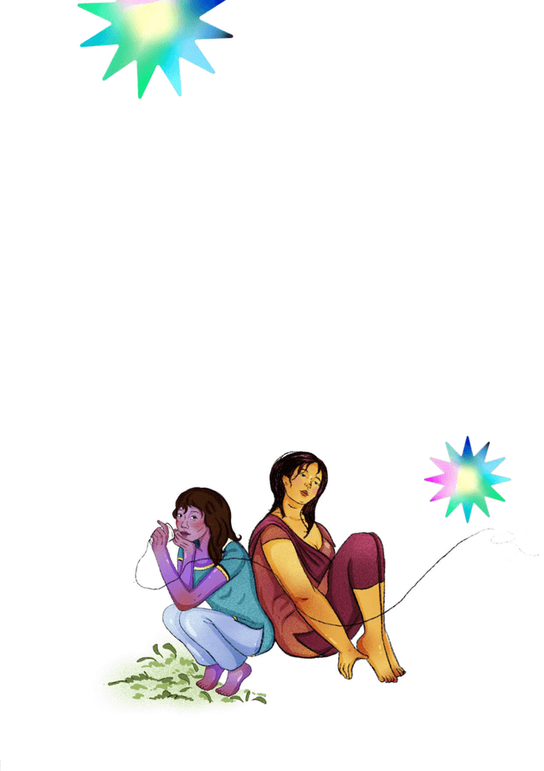**OUR**

**PARTNERS!**

We are deeply grateful to our partners for their critical support in resourcing our work. A heartfelt thank you goes out to the Founda-tion for a Just Society (FJS), Open Society Foundations, NUMUN Fund, Women’s Fund Asia, and the Astrea Lesbian Foundation for Justice for resourcing our work and believing in our mission. Their contributions have enabled us to continue making a meaningful impact in the digital rights space, ever since the establishment of Body & Data.

In 2024, the financial support we received helped fuel a wide range of initiatives, including our organizational development, office relocation, CPCL fellowship, capacity-building programs, and advocacy campaigns. These funds have been instrumental in the growth of our programs, and strengthening of our organization, team and communities. We are committed to being transparent and accountable to our partners, ensuring that the resources we have continue to create real, lasting change in the years ahead!

17

**LOOKING FORWARD TO 2025!**

In less than six months of 2025, we’ve already been busy laying the groundwork for an exciting year ahead. We have actively engaged in a range of events and workshops, including those organized by ILGA Asia, CREA, and RightsCon. These engagements have strengthened our regional and global networks and reinforced our ongoing com-mitment to advancing digital rights. We are also creating the CPCL Learning Portal, which will make resources on Countering Protec-tionism and Criminalization of Online Sexual Expression accessible. We will also be disseminating the work of our CPCL fellows through the portal. Additionally, we launched Chiya Charcha, a collective feminist conversation bringing together individuals working in multiple spheres with the aim of cross movement strengthening. There’s a lot more to come, and we’re excited for the year ahead!.



18