# [Opening segment]

At Body & Data we’ve always embraced organizational growth as a journey of change; from inception we’ve acknowledged that people, movements and organizations all walk this path of ebb and flow. Building on our core values and yet evolving to remain at pace with the times, and yet also having space to pause and allow reflection, we see this as the rhythm of feminist praxis. We believe that it is this versatility that can take into account balancing feminist values with the day-to-day challenges of leadership.

Looking back at 2023, it has been a year of transition for Body & Data. As part of a long-planned leadership change, we’ve bid farewell to our former Executive Director and the Co-Founder of Body & Data, Shubha Kayastha, who is now pursuing her PhD; we’re excited to see her off on her own journey within academia and look forward to her contributions to the digital rights sector in the future. Multiple transition related programs and Organizational Development activities and policy building were also part of our preparations for leadership change and have contributed to our year of growth and change.

Amidst this backdrop, we’re also proud to have continued our activism towards digital rights and digital justice, whether in terms of taking on issues of national gravity such as the National Identification Card project, Dalit rights in digital spaces, or connecting with local communities through the medium of radio. We’re also elated to have 12 legal fellows onboard as part of our fellowship program to critically analyze Nepal’s legislation on online sexual expression.

The trajectory of 2023 has also provided us, the Board of Directors, opportunities to participate even more in Body & Data’s journey. As we steer Body & Data during this interim and move forward with organizational development and establishing of new leadership, we would like to thank our many well-wishers at home and abroad for their support, trust, advice, constructive criticism and care. We look forward to continuing in this path, and are eager to see how 2024 unfolds, formulating brave new directions for Body & Data as a pioneering feminist digital rights organization.

Bharat Man Shrestha, and Supriya Manandhar

*Board Chair, and Board member (former Chair)*

# Knowledge Generation in Digital Rights

## Digitization of Identities: Efforts, Experiences and Effects

“Digitization of Identities: Efforts, Experiences and Effects” is a pilot study conducted by Body&Data. It contributes to a growing body of global research on national digital ID programs. It sheds light on the discrepancies between the envisioned benefits and the practical realities of implementing such systems in Nepal's NID program. The study raises concerns about the potential for biometric IDs to extend beyond simple identity verification and authentication. The continuous collection, processing, and sharing of unique biometric data could lead to a state of near-constant surveillance, potentially infringing on digital rights in the pursuit of perceived technocratic, bureaucratic, and market efficiencies. Additionally, the program's design might inadvertently exacerbate existing social and economic marginalization.

Data was collected from districts including Panchthar (Phidim Municipality and Yangwarak Rural Municipality), Jhapa (Mechinagar Municipality, Kachankabal Rural Municipality, and Baradashi Rural Municipality), and Kathmandu.

This report highlights the limitations of biometric ID systems as a universally applicable solution for legal identification. The experiences of participants in Nepal's National Identity Card program mirror concerns identified in global research. It puts emphasis on the need for a more nuanced approach that balances security and convenience with the protection of individual rights and the inclusion of marginalized communities.

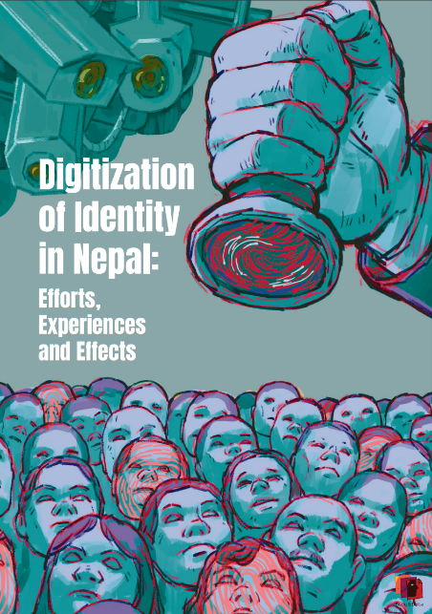

Figure 1 Front Page of the report, "Digitization of Identity in Nepal: Efforts, Experiences and Effects"

## Twelfth Annual Kathmandu Conference on, "Nepal and the Himalaya" organized by Social Science Baha

At the Twelfth Annual Kathmandu Conference on "Nepal and the Himalaya," organized by Social Science Baha, Body & Data's team shared the ongoing research on National ID cards and the privacy concerns of marginalized populations in Nepal. The presentation generated significant discussion on the need of a feminist approach to digital rights to understand the disproportionate impact on marginalized individuals. This approach recognizes the unequal impact technology can have on marginalized groups. The team also highlighted that there is are rising risks associated with the lack of transparency and informed consent during Nepal's National ID digitalization process. Body & Data emphasized the critical need to prioritize privacy over convenience when handling sensitive biometric data. A feminist approach to digital rights can lead to solutions that address the unique challenges faced by marginalized individuals in the digital world.

Body & Data has submitted two papers for the Twelfth Annual Kathmandu conference on, "Nepal and the Himalaya":

1. Navigating Digitization of Identities: A Feminist Analysis of Nepal's National ID Program
2. Privacy in the digital age and as understood by marginalized groups in Nepal

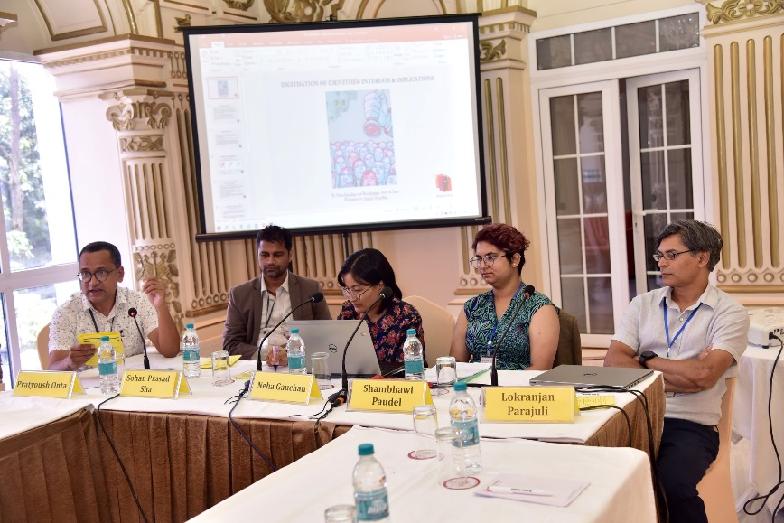

Figure 2Body&Data team in the Social Science Baha Conference, 2023.

### Navigating Digitization of Identities: A Feminist Analysis of Nepal's National ID Program

This study examines Nepal's adoption of a national digital ID (NID). Biometric data collection, both exceptional and commonplace in Nepal, is explored as a driver of digital governance. The research focuses on the NID's impact on marginalized communities, particularly regarding privacy and data security. It goes beyond classification, considering the embodied effects of biometrics. By going "beyond classification," the research acknowledges that NID's impact goes beyond simply categorizing people. It explores the tangible ways this system affects how marginalized communities experience privacy and data security in their daily lives.

Drawing on the two-phased 2019-2023 research in five districts (Panchthar, Jhapa, Khotang, Sarlahi, Kathmandu), the study reveals a lack of transparency and informed consent in the NID's rollout, raising concerns. Impacts extend beyond administrative issues, potentially affecting long-term data privacy and bodily autonomy. The research expands the privacy discussion beyond traditional "private" and "public" views, incorporating feminist perspectives to understand the experiences of marginalized communities and their right to self-determination.

While digital IDs offer convenience, they can compromise human rights and data justice. This paper argues for prioritizing marginalized identities and the sensitivity of biometric data. It emphasizes placing communities at the center of discussions and making privacy a core principle, not an afterthought, in digital governance.

### Privacy in the digital age and as understood by marginalized groups in Nepal

Western perspectives often frame data as a personal asset individuals can control. In Nepal, where internet access and digital literacy might be lower, marginalized communities might have less agency over their data. This study aimed to be more inclusive by focusing on the experiences of these groups. Through discussions with young women, LGBTQIA+ individuals, people with disabilities, and Madhesi youth, the study explored their understanding of privacy in various contexts. These included physical and digital spaces, family, relationships, work, and social media.

The findings revealed a nuanced view of privacy, shaped by personal experiences, gender, sexuality, and social identity. For some, privacy was deeply linked to dignity. This could lead to sharing private information strategically, hoping to influence policies that address their needs. Interestingly, some participants felt comfortable sharing personal details about mental health, sexuality, or relationships in digital spaces. Their comfort seemed to depend on trust and a sense of "safety and non-judgment." Consent was also crucial, with participants expecting information to be kept confidential unless further sharing was explicitly agreed upon. The study highlighted a gap between Nepal's existing privacy regulations (focused on a binary public/private divide) and the lived experiences of marginalized groups, where it is important to consider that the laws don't reflect how these communities experience privacy in their daily lives.

## ISS Gender, Society and Tech: An analysis from a gender perspective

On March 17, 2023, to coincide with International Women's Day celebrations, Body & Data organized Internet Swatantrata Samwaad (ISS) titled "Gender, Society and Tech: A Gendered Perspective in the Nepalese Context."

This session explored the intersection of gender, societal norms, and technology use in Nepal. Discussions focused on critical digital rights issues faced by women, queer, person with disabilities and marginalized communities. The discussion explored how online violence, privacy concerns, and imposed surveillance impact free expression, particularly for marginalized communities like sex workers, Dalits, and the queer community. Privacy and autonomy are fundamental to their work, activism, and movement. This is especially true given the constant control and monitoring they face within Nepal’s patriarchal society.

The speakers addressed the challenges of tech and internet inaccessibility for marginalized communities and its detrimental impact on their lives. The discussion focused on how limited access to technology and the internet disproportionately affects marginalized communities. This lack of access creates significant barriers, hindering their ability to find education and employment opportunities, increasing social isolation, and even limiting participation in essential services that are increasingly moving towards digitalization.

A purple coloured poster for the vent, " Gender, Society and Tech: An Analysis from a Gender Perspective"
Moderator: Kabita Bahing, Programme Coordinator and Operations, Body & Data

Speakers:
1. Dikshya Khadgi, Feminist Legal Practitioner and Researcher
2. Rita Baramu, Programme Officer, Body & Data
3. Sarita Lamichhane, Disability Rights Activists, Prayatna Nepal

Figure 3Poster for the Internet Swatantra Sambad, " Gender, Society and Tech: An Analysis from a Gender Perspective"

## ISS The Dalits in the Digital Rights Discourse

The second Internet Swatantrata Samwaad (ISS) focused on "Dalits in the Discourse of Digital Rights" and was held on October 12, 2023. This session presented research findings exploring the intersection of caste and digital rights. The program discussed the experiences and challenges faced by Dalit communities in online spaces.

Dalit women face the challenge of double discrimination based on caste and gender. This can lead to self-censorship or censorship by others, often for safety reasons. While the digital medium has proven effective in disseminating news and information about Dalit issues, the report acknowledges that online spaces mirror existing societal structures of prejudice. True change in the online sphere for Dalit women can only occur alongside broader societal transformation, as the current hierarchical and exclusionary nature of society replicates itself online through caste-based discrimination. The panel emphasized the potential of digital media as a tool for Dalit joy and self-liberation. Speakers pointed to the power of online spaces for sharing success stories and fostering mutual encouragement within the Dalit community. They also highlighted the role of digital platforms in building solidarity and celebrating each other's achievements.

On the occasion of Cyber Security Awareness Month (CSAM) and also as a part of Internet Swatantrata Samwaad ISS (Internet Freedom Conversation) we have brought to you, “The Dalits in the Digital Rights Discourse”. This is a part of an extension of our work to dissect and analyze the conversation around technology and its influence on our society from the intersectional perspective of marginalized communities. Among various themes, we explored ways in which marginalised folks, especially Dalit peoples’ access mobile devices and technology, their expressions of opinions and dissent alongside engaging in movement building, issues of privacy and surveillance and experiences of violence online, and many more.

We are excited to share with you our preliminary findings and share a panel discussion afterwards. Please find the details of the event below 

Event Title: The Dalits in the Digital Rights Discourse 
Time: 2 PM - 5 PM
Date: 12 October 2023 (Thursday)
Venue: Martin Chautari, Thapathali, Kathmandu 

Moderator: Gauri Nepali (Federation of Sexual and Gender Minorities) 
Presenter: Dikshya Khadgi (Independent Researcher) 
Speakers: Bikash Biswokarma (Dalit Yuva Jagaran Manch Nepal) & Sunita Pariyar (Samata Foundation)
Special Speaker: Anisha/Aneekarma (Province Co-ordinator, Body&Data)

Figure 4 Poster for the event, "The Dalits in the Digital Rights Discourse"

* 1. Media Monitoring Report 2023

## NEPAL: ‘The TikTok ban signals efforts to control the digital space in the name of national sovereignty’ by CIVICUS

<https://www.civicus.org/index.php/media-resources/news/interviews/6721-nepal-the-tiktok-ban-signals-efforts-to-control-the-digital-space-in-the-name-of-national-sovereignty>

Anisha, Body and Data’s Gandaki Province Coordinator, spoke with CIVICUS, a global alliance advocating for civil society, regarding the repercussions of Nepal's TikTok prohibition. It was stressed that TikTok's prohibition affects a wide-ranging audience, particularly marginalized communities, indicating a notable restriction on freedom of speech. This apprehension escalates given the proposed legislation for social media regulation, as the ban extends beyond mere entertainment, potentially suppressing diverse voices and limiting the creative expression of marginalized groups.

Additionally, the discussion also highlighted that banning a digital platform is a means for the government to control citizens, marking one of the strongest forms of surveillance by taking away freedom of expression. This adds to global debates on digital rights, highlighting the tension between online regulation and individual rights. Ultimately, the ban on TikTok raises broader questions about the future of digital platforms and sparks discussions on user education, advocacy efforts, data privacy, regulation, and surveillance in our digital world.

## Rethinking The NID: Inclusion, Data Justice, and Tech Solutionism with PODS by PEI

<https://podcast.pei.center/episode/rethinking-the-nid-inclusion-data-justice-and-tech-solutionism>

Body & Data joined PODS by PEI, a podcast initiative by the Kathmandu-based policy research center Policy Entrepreneurs Inc. (PEI). In this episode we delve into the National Identity (NID) program in Nepal with the host Khushi Hang.

The conversation explores the NID program within the broader context of digitization in governance practices, tracing the NID’s development, highlighting key actors and events that have raised questions. The conversation also includes an evaluation of risks and vulnerabilities associated with the digitalization project and digitization of governance in general, and also covered the need of inclusivity, data security, data justice, and avoiding overreliance on technological solutions for complex issues.

## Content Creation

In the year 2023, Body & Data has explored crucial topics at the intersection of digital spaces and our communities' lives, including: Sexual and Reproductive Health and Rights, online violence and discrimination, freedom of expression, sexual pleasure, surveillance, and digital accessibility.

### Articles:

1. [Anonymous Comfort](https://bodyanddata.org/anonymous-comfort/)
2. [How Musk’s Twitter Buyout May Do More to Cage The Bird Than to Free It.](https://bodyanddata.org/twitter-buyout/)
3. [My Love-Hate Relationship with Dating Apps](https://bodyanddata.org/my-love-hate-relationship-with-dating-apps/)
4. [डिजिटल दुनियाँ कहिले बन्छ अपांगतामैत्री ?](https://bodyanddata.org/when-will-digital-space-become-accessible-nep2/)
5. [Inclusion Matters: Towards Comprehensive sexual Edu for women with disabilities in digital age](https://bodyanddata.org/srhr-internet-disability/)
6. [There is no one single story to pride](https://bodyanddata.org/there-is-no-one-single-story-to-pride/)
7. [Lletter- to -Journalist](https://bodyanddata.org/letter-to-journalist/)

# Body & Data Legal Fellowship

# Body & Data Legal Fellowship

Body & Data Legal Fellowship is a year-long program to explore the digital rights situation in Nepal's Bagmati and Gandaki provinces. The Fellowship is a dedicated team of 12 lawyers with diverse backgrounds and experiences. Together, they are working to make the internet a more inclusive and respectful space where everyone's rights and dignity are protected.

Their focus is on analyzing Nepal’s laws that unfairly restrict online freedoms, especially for women, LGBTQIA+ individuals, and marginalized communities. The Fellowship counters the protectionist lens often applied to online sexual expression, aiming to challenge stereotypes and prejudices and promote a more open and rights-based approach. Through constructive discourse and advocacy efforts, the fellows seek to shape policies that respect individual autonomy and dignity online.

## Digital Rights and Consultation Workshop – Gandaki Province

In an effort to advance digital rights advocacy and foster collaborative efforts in Gandaki Province, Body & Data organized a two-day workshop titled "Digital Rights and Consultation Workshop." The workshop brought together stakeholders from diverse backgrounds, including Dalit rights activists, journalists, queer rights activists, disability rights activists, women's rights activists, children's rights activists, and lawyers.

With a primary focus on stakeholder mapping, networking, and issue identification surrounding digital rights, particularly emphasizing criminalization, the workshop aimed to galvanize collective action and build capacity for future interventions.

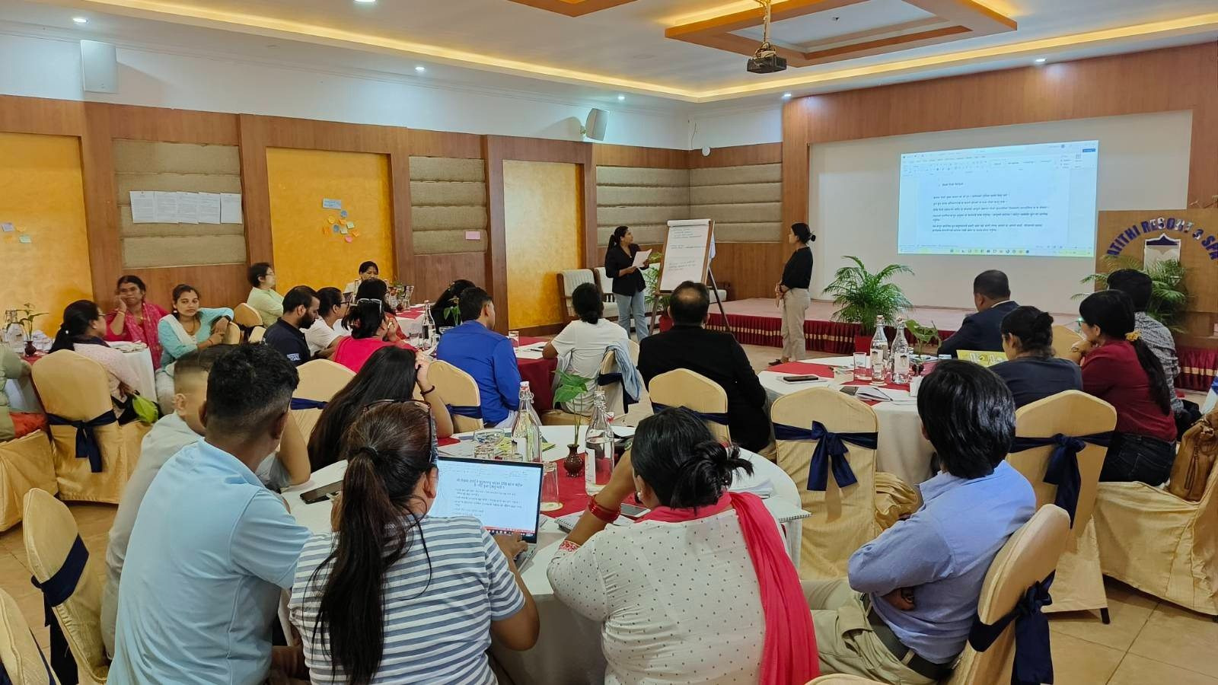

Figure 5 Glimpse of digital rights and consultation workshop.

## Orientation Workshop with B&D Legal Fellows:

In October 2023, Body & Data facilitated the Cohort Orientation Workshop as part of the fellowship program. Held at the scenic Godawari Village Resort, the workshop welcomed a total of 12 fellows, marking the commencement of their journey towards championing digital rights advocacy. The workshop agenda encompassed various objectives aimed at fostering a comprehensive understanding of digital rights, law, and criminalization within the Nepali context. Participants engaged in introductory sessions, acquainting themselves with fellow cohort members and the administrative aspects of the Body and Data organization.

Through interactive discussions and capacity-building exercises, fellows delved into the nuances of digital rights and unpack the concept of criminalization, empowering fellows to critically analyze its implications within their respective communities. As participants set forth their fellowship agreements and commitments, the orientation workshop laid a foundation for collaborative learning and advocacy efforts throughout the fellowship journey.

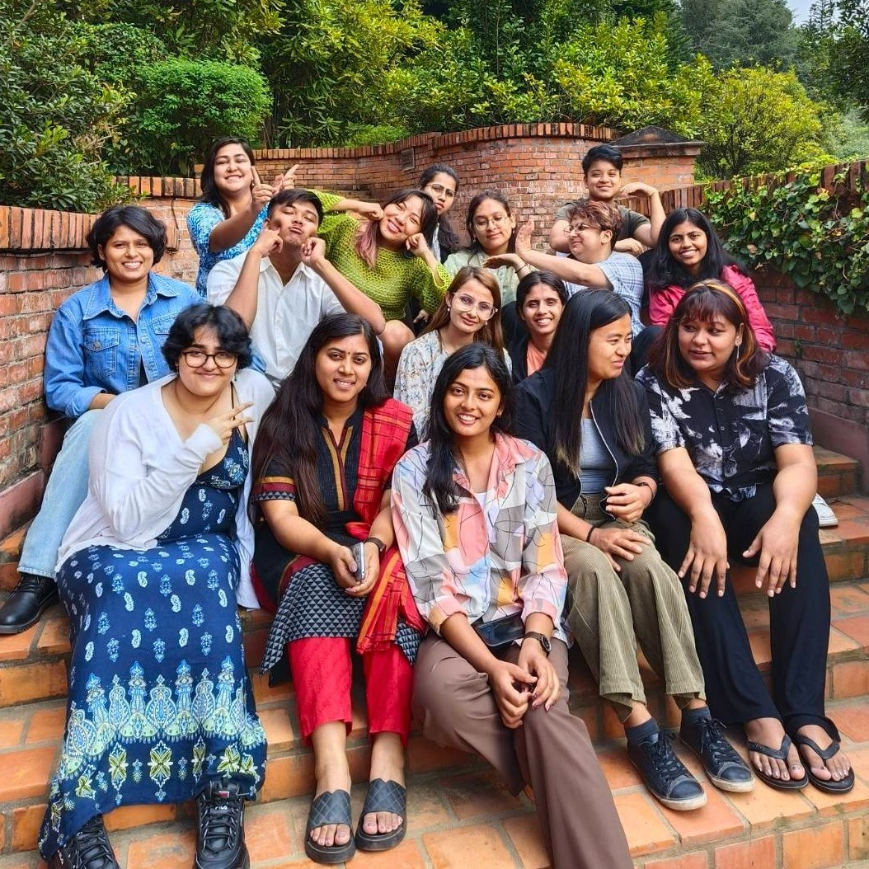

Figure 6 Group photo of Body&Data's Legal Fellowship Orientation Workshop.

# Advocacy and Campaign:

## Election in Nepal: Voters' Privacy Concerns

“*Privacy Matters Beyond Ballot!*”

With more data being collected and people spending more time online, protecting privacy rights is more important than ever. That's why Body & Data has been actively working to raise awareness on privacy rights, especially during elections. Privacy is essential during elections to ensure that the voters can make free choices without intimidation. Data leaks can be used for targeted messaging, coercion, or limit exposure to diverse viewpoints.

During Nepal's second general election in November 2022, the Election Comission made the voters' data publicly available on their website. This action had led to a serious breach of data privacy, as it made voters' private information easily accessible to the public. During this period, Body & Data brought this matter to light and urged the EC to remove voters' personal data from their website.

In 2023, we came to know that the EC was in the process of drafting a new guideline consolidating various electoral laws. Our primary concern is whether these forthcoming guidelines adequately address the issue of voter data protection. In light of these events, there are significant risks and concerns regarding the protection of personal information. As an effort to raise awareness about the importance of voter data privacy among the public and relevant stakeholders, Body & Data had a month-long online campaign where we disseminated materials on privacy and its intersection with elections. Additionally, Body & Data received nine screenshots of political advertisements distributed to individuals on their private phone number from unidentified sources. This underscores a significant concern of the accessibility of private phone numbers to political campaigns. This accessibility may be attributed to the fact that the Electoral Commission has made voter data publicly accessible on their website.

To understand the weight of this issue, Body & Data spoke to Jalasa Sapkota, a disability rights activist, and Monisha Choudhary, a lawyer and activist. They voiced their concerns about political data leaks and their impact on people's lives, which has been shared in [visual](https://www.instagram.com/p/CwCJDHhPbso/?utm_source=ig_web_copy_link&igsh=MzRlODBiNWFlZA==) and [audio formats](https://www.instagram.com/reel/CwPAKQmocv9/?utm_source=ig_web_copy_link&igsh=MzRlODBiNWFlZA==) via our social media platforms.

Red background with text on top which reads as, "Election in Nepal; Voters' Privacy Concerns", "Privacy Matters Beyond Ballot!"

There is a pie graph which shows which political party spend the most in the 2022 general election. It shows that the Swatantra Umedwar spent the highest i.e. 43.8%.

Figure 7An illustration depicting which political party has invested the highest in Facebook political advertisements.

## Body & Data in solidarity during the [#16DaysofActivism](https://www.instagram.com/explore/tags/16daysofactivism/)

In 2023, during the global campaign of 16 Days of Activism against Gender-Based Violence, Body&Data released a statement expressing our solidarity for the cause. The statement recognized that the internet can be a platform where GBV manifests. We advocate for a more nuanced approach beyond looking at the internet from a violence-centric approach. This means acknowledging the role the internet plays in promoting free expression and digital rights, while simultaneously working to create safe online spaces for all.

Gender-Based Violence stands as a significant issue amid various types of violence stemming from political, social, cultural, religious, and economic exploitation, discrimination, and inequality. Numerous efforts are underway at various levels to address this pressing concern. In light of this, we, Body & Data, wish to express collective solidarity during the 16 Days of Activism against Gender-Based Violence, a global initiative taking place annually from November 25 to December 10. Additionally, we emphasize the urgent need to delve into the multifaceted nature of Gender-Based Violence.

In the neoliberal era and within the capitalist system, the Internet and technological tools have evolved into different instruments for various forms of Gender-Based Violence, which have become increasingly complex. However, the prevailing narrative attributing the rise in cybercrime and sexual violence solely to the Internet and technology is overly simplistic. As an organization dedicated to studying and advocating for digital rights, Body & Data rejects such inadequate and one-sided perspectives. On one hand, these viewpoints divert attention from the root causes of the problem, and on the other, they widen the path to suppress our rights to opinion and expression on the Internet. Moreover, such perspectives not only hinder the environment for organizing and solidarity online but also jeopardize the open, free, and non-violent nature of the internet. Our research indicates that, despite the violence experienced, the Internet and technology provide women and individuals from marginalized groups with numerous opportunities for campaigning and expressing themselves. There are instances of victims using social networks to publicize the violence they have endured and seek psychological and/or legal assistance.

Currently, alongside the commentary regarding the increase in cybercrime and violence attributed to the Internet and technology, there is a prevailing notion that social harmony, morals, ethics, and values have been compromised. The government itself is at the forefront of addressing this concern, hastening the issuance of laws and guidelines related to social networks, including the banning of platforms such as TikTok. This approach, however, has adversely affected the rights of women and marginalized individuals to express themselves and live without fear of violence. We strongly condemn these actions and urge the government and relevant agencies to prioritize a humanitarian and human rights-oriented approach in formulating policies and rules related to the Internet, technology, and social networks.

Body & Data
Bhaktapur
11/25/2023

Figure 8Solidarity in the Activism against Gender-Based Violence and a Focus on the Violation of the Right to Expression!

राजनीतिक, सामाजिक, सांस्कृतिक, धार्मिक तथा आर्थिक शोषण, विभेद र असमानताका कारण सिर्जित धेरै थरिका हिंसाहरूमा मध्ये लैंगिक हिंसा प्रमुख समस्या मध्येको एक हो, जसको निराकरणका लागि धेरै तहबाट निरन्तर प्रयास जारी नै छ। यसै सन्दर्भमा हरेक वर्ष नोभेम्बर २५ देखि डिसेम्बर १० सम्म विश्वव्यापी रुपमा आयोजना गरिने लैंगिक हिंसा विरुद्धको १६ दिने अभियानमा हामी बडी एण्ड डाटाको तर्फबाट सामूहिक ऐक्यबद्धता व्यक्त गर्न चाहन्छौँ । यसका साथै लैंगिक हिंसाका बहुआयामिक स्वरूपमा समेत व्यापक छलफल गर्नु पर्ने गहिरो आवश्यकता औँल्याउन चाहन्छौँ । 

नव उदारवादी समय र पुँजीवादी व्यवस्थामा लैंगिक हिंसाका स्वरूपहरू बहुआयामिक हुँदै गर्दा थप, इन्टरनेट र प्रविधिका माध्यमहरू पनि लैंगिक हिंसाका फरक साधन बन्दै गई रहेको हामीले पाएका छौं । यद्यपि, इन्टरनेट र प्रविधिकै कारण साइबर अपराध र लैंगिक हिंसा बढेको मूलधारे भाष्य पनि स्थापित हुँदै गएको छ । हामी बडी एण्ड डाटा, डिजिटल अधिकार सम्बन्धी अध्ययन र वकालत गर्ने संस्थाको हैसियतले यस्तो खाले अपुरो र एक पक्षीय भाष्य अस्वीकार गर्छौ । यस्तो भाष्यले एकातिर समस्याको मूल कारणलाई नहेरी त्यसको विषयान्तर गर्छ भने अर्कोतिर इन्टरनेटमा हाम्रो बिचार तथा अभिव्यक्तिको अधिकारलाई कुण्ठित गर्ने बाटो फराकिलो बनाइदिन्छ । त्यतिमात्र नभई हाम्रो इन्टरनेटमार्फत सङ्गठित हुने र खुला, स्वतन्त्र र हिंसा रहित इन्टरनेट प्रयोग गर्ने वातावरण समेत दुषित गरिदिन्छ । हाम्रो अध्ययनहरूले पनि इन्टरनेट र प्रविधि मार्फत महिला तथा सीमान्तकृत बर्गका व्यक्तिहरूले त्यहाँ भोगेको हिंसाका बावजुत आफ्नो अभियान र अभिव्यक्ति लगायतका धेरै अवसरहरू पाउने गरेको देखाउँछ । अझ सामाजिक सञ्जालकै माध्यमबाट आफू माथि भएका हिंसा सार्वजनिक गर्ने र त्यसको मनोवैज्ञानिक या कानुनी उपचारमा जाने अवसर पीडितहरूले पाउने गरेको प्रशस्तै उदाहरणहरू भेटिन्छन् । 

हाल इन्टरनेट र प्रविधि कै कारण साइबर अपराध र हिंसा बढेको भाष्य जस्तै यसकै कारण सामाजिक सद्भाव, सदाचार, नैतिकता र मूल्यमान्यतामा आँच आएको भाष्य पनि व्यापक देखिन्छ । जसमा सरकार स्वयम् अग्रभागमा बसेको छ र यसलाई नियमन गर्न सामाजिक सञ्जाल जस्तै टिकटकमा प्रतिबन्ध लाउने, डिजिटल/मानव अधिकारमा प्रहार हुने गरी सामाजिक सञ्जाल सम्बन्धि कानुन या निर्देशिका जारी गर्ने काम सरकारले तीब्र गर्दै लागेको छ । यस्ता कार्यले माथि भने जस्तै महिला तथा सीमान्तकृत अभिव्यक्ति र हिंसा रहित बाच्न पाउने अधिकारलाई आघात पुर्याएको छ, जसको हामी भर्त्सना गर्दछौँ । र सरकार लगायत सम्बन्धित निकाय समक्ष इन्टरनेट, प्रविधि र सामाजिक सञ्जाल सम्बन्धि नीति नियम निर्माणमा मानवीय र मानव अधिकारमुखी पद्धतिलाई ध्यान दिन विशेष माग गर्दछौँ । 

बडी एण्ड डाटा 
भक्तपुर 
९ मङ्सिर, २०८०

Figure 9लैंगिक हिँसा विरुद्धको अभियानमा एक्येबद्धता र अभिव्यक्ति अधिकार हनन भएकोमा ध्यानाकर्षण !

## Gandaki Radio Campaign

In an effort to produce and generate knowledge on digital rights and their aspects at a local level beyond the capital city, Body & Data, initiated a collaborative project with 20 community radios from Gandaki Province in 2022. This project aimed to produce and disseminate knowledge on digital rights and their local implications.

The collaboration began with two preliminary workshops with the representatives from the Gandaki community radios, known for their work on social issues. These workshops served a dual purpose: we gained valuable insights into the digital rights landscape at the grassroots and learned about alternative media and communication channels beyond online and social media platforms. Conversely, the participating community radios gained a deeper understanding of the importance of digital rights in their own work.

Building on the workshops, we partnered with Marsyangdi Radio, a community radio station in Lamjung. Together, they co-created and co-produced radio programs focused on raising awareness about privacy, data protection, internet access, online safety during local elections, and the broader concept of human rights in the digital sphere. The collaboration produced and aired six episodes across 20 Gandaki-based community radios. Additionally, [these episodes](https://www.youtube.com/watch?v=y_wFt_OiHxw&list=PLek7qiQa6B4QKY1fEzlEMaS83VQJgtH4g&pp=iAQB) have been shared on Body & Data's social media platforms for further dissemination.

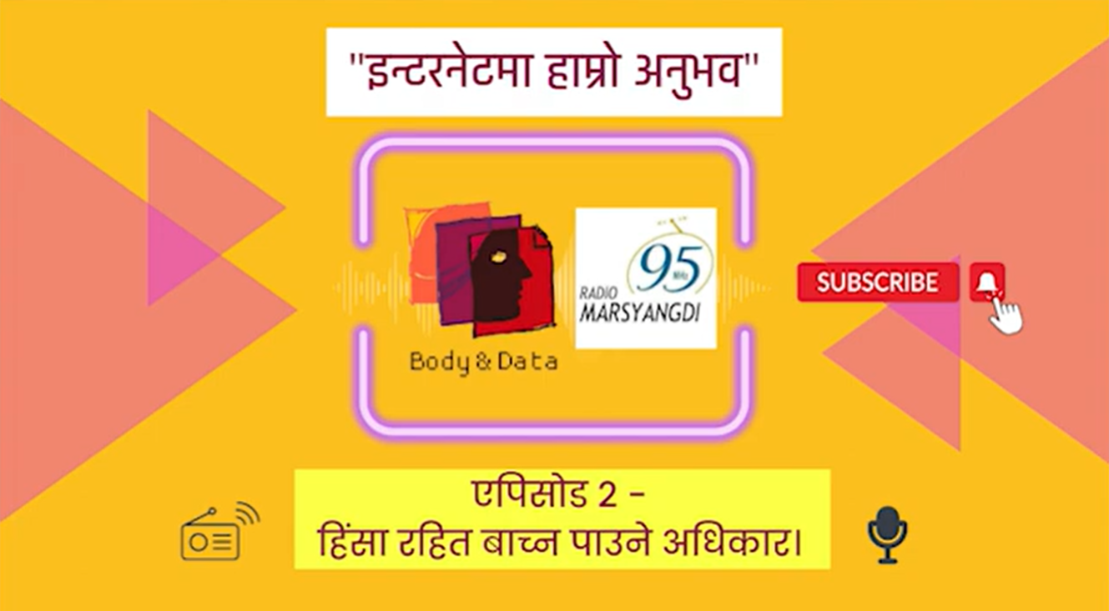

Figure 10"ईन्टरनेटमा हाम्रो अनुभव", radio program by Body&Data.

# Capacity Building Workshops

## Website Accessibility Workshop

At Body & Data, we believe in equal access to information and technology. That is why making our content accessible is a core value. To further this commitment, we recently hosted a 2-day website accessibility workshop for our team. This workshop equipped us with the knowledge to create more inclusive social media platforms and documents. The workshop explored the importance of making websites, social media content, videos, and documents accessible to users with disabilities. Our team learned various techniques to achieve this, including the effective use of alt text for describing images, utilizing color combinations with good contrast, and implementing a proper structure of headings (H1, H2, etc.) for improved navigation with assistive technologies. We would like to thank Sagar Prasai, Kushal Neupane, and Santosh Ghimire from Diverse Patterns for this workshop on website accessibility. Their expertise has helped us to create more inclusive digital content, fostering a more accessible work environment.

## Feminist Tech eXchange

The Feminist Tech Exchange (FTX) offers digital security workshops that explore the intersection of gender, sexuality, and digital rights. These workshops go beyond discussions by providing practical training on tools and strategies for safer online experiences. FTX welcomes participants from various backgrounds, including individual activists, women, LGBTQ+ folks, social justice organizations, and anyone interested in the topic. In total, there were total of 4 FTX workshops this year, focusing especially on marginalized communities. By working primarily with LGBTQ+ people, women, and those with disabilities, we were able to engage a total of 74 participants in important conversations about digital rights.

### Feminist Tech eXchange by Body & Data

This year, Body & Data organized 2 Feminist Tech eXchange (FTX) workshops in May and June. These workshops brought together 39 people from different backgrounds to discuss digital rights in a safe space. The key areas explored during these discussions encompassed technology and internet accessibility, inclusivity, freedom of expression and association within online platforms, the political ramifications of data privacy, and the aspects of surveillance. Overall, the workshops fostered important conversations that intertwined digital rights issues with their own personal experiences. If you are curious about the things, we discussed in this workshop read [our blog](https://bodyanddata.org/digital-rights-concerns-discussion-from-feminist-tech-exchange-2023/) now!

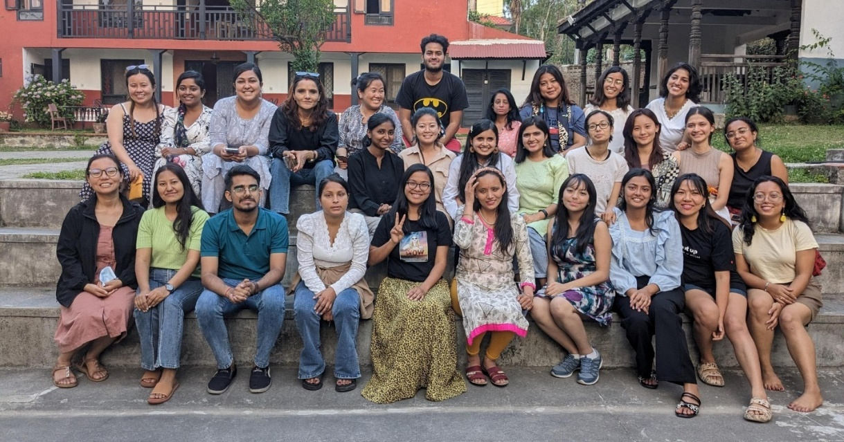

Figure 11 Group photo of the FTX, 2023.

### Feminist Tech eXchange in Collaboration with Prayatna Nepal

In collaboration with Prayatna Nepal, a leading advocate for the rights of Women with Disabilities, Body & Data organized a three-day digital security workshop. The workshop covered essential topics such as digital rights, data management and access strategies, and effective digital security and data privacy practices. The program also explored accessible tools and technologies for users with disabilities.

Discussions revealed that there are significant accessibility challenges faced by participants in the digital space. Women with disabilities shared experiences of online threats, privacy violations, and limitations on their freedom of choice and expression. These issues highlighted the urgent need for increased focus on universal design principles, ensuring both physical and digital accessibility. To learn more about this workshop head over to the [blog](https://bodyanddata.org/digital-security-workshop-with-prayatna-nepal/) in our website.

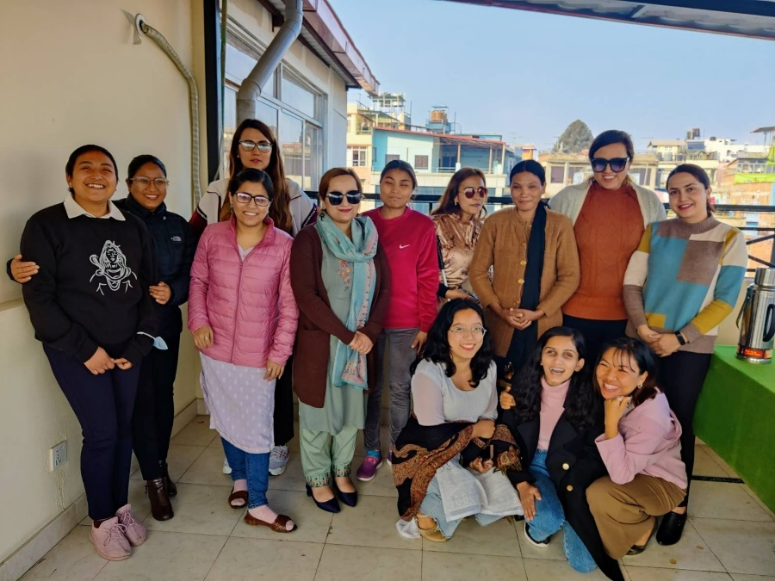

Figure 12 Group photo of the FTX with Prayatna Nepal.

### Feminist Tech eXchange in Collaboration with ADWAN

Body & Data in collaboration with Asociation for Dalit Women Advancement of Nepal (ADWAN) team in Chitwan, conducted a three-day digital security workshop. ADWAN is a organization which works for the equality and empowerment of Dalit & marginalized people in Nepal. The workshop targeted 25 members from the ADWAN team and its fieldwork teams, all actively involved in the Dalit rights movement across various districts (Kathmandu, Gorkha, Chitwan, and Butwal).

This workshop aligned with our strategic objective for the year, which focuses on empowering women human rights defenders, particularly those from the Dalit community, by equipping them with digital rights knowledge. The workshop provided a platform for participants to share their experiences navigating the digital divide and limited access to technology. Discussions revealed a pattern of online experiences mirroring real-life challenges, including caste-based discrimination, violence, and disrespectful behavior. Participants also explored concepts of digital security and data privacy, with the goal of being able to implement these practices within their organization.

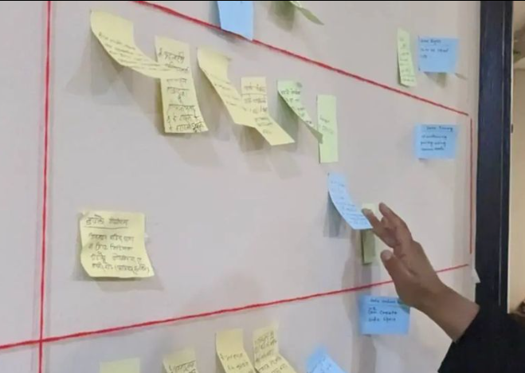

Figure 13 Glimpse into the ADWAN workshop.

## Katha Kaa Kura: Stories of Digital Resistance

KathaKaa Kura workshop helps women, LGBTQIA+ folks, and marginalized communities use digital storytelling to show how their lives are connected to the web of digital spaces. This workshop is not just about telling stories but it is also about the use of technology, like photos or videos, to show how the internet and tech tools affect their everyday experiences.

This year, 12 individuals collaborated with the Body & Data to co-create stories that look into their relationship with the digital world. By fostering a safe space for sharing and co-creation, KathaKaa Kura amplifies the voices of those with marginalized identities. Through the power of digital storytelling, these workshops showcase the diverse realities and experiences of these individuals. You can find their stories in our official [YouTube channel](https://www.youtube.com/watch?v=BCpzfj2waU8&list=PLek7qiQa6B4Qe9HBni3U0Z855AC0P17fv&pp=iAQB).

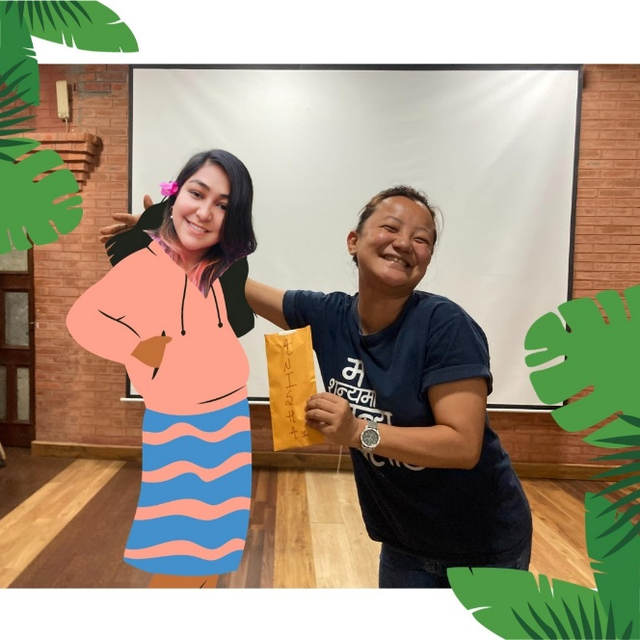

Figure 14 A glimpse into Katha ka Kura, 2023.

# Cross-movement Collaborations

## Asia Pacific Regional CSO Forum on the priority theme of CSW67

Body&Data, participated in the Asia Pacific Regional CSO Forum on the priority theme of CSW67 alongside CSOs from across the Asia-Pacific region. The forum was centered on "Innovation and technological change, and education in the digital age for achieving gender equality and the empowerment of all women and girls." Discussions explored critical issues surrounding online gender-based violence, the implications of digitalization in development practices, big tech companies' accountability, and the impact on various genders and marginalized groups.

During the event, Body & Data stressed the urgency of adopting an inclusive, intersectional perspective during the forum. We highlighted the challenges faced by marginalized communities in terms of accessibility, affordability, and sustainability issues, hindering their meaningful access and participation in the digital transformation process.

## CSW67 Engagement

Body & Data, participated in the 67th Commission on the Status of Women (CSW67) held in March 2023. The main theme was “Innovation and technological change, and education in the digital age for achieving gender equality and the empowerment of all women and girls".

At the CSW, Body & Data highlighted the need for an intersectional approach to bridging the digital divide. We emphasized the need for clear communication on technological privacy. Technical jargon often makes it difficult to explain these issues to communities in a way that reflects their real-world experiences and how they use technology in practice. Body & Data addressed this challenge by participating in various sessions as panelists, moderators, and attendees.

## DRAPAC23 at Chaing-Mai, Thailand

Body & Data Team, participated in the DRAPAC23 program organized by Engage Media in Chiang Mai, Thailand. We participated in various events and organized an exhibition showcasing Body & Data’s artwork exploring the intersection of technology and the internet. Additionally, we also participated in a plenary session, "Digitization of Identities in the Asia-Pacific through a Data Justice Lens,". The discussion highlighted concerns surrounding state-led e-governance initiatives, particularly their impact on marginalized communities. These communities face several hurdles: limited access to internet and smartphones creates a digital divide, while electronically stored personal data raises privacy concerns, potentially amplifying existing vulnerabilities. Additionally, costs associated with obtaining or using digital IDs can further exclude them. Lastly, security breaches in these systems pose a significant risk for those relying heavily on them. Careful design and implementation are essential to ensure e-governance initiatives don't widen existing inequalities.

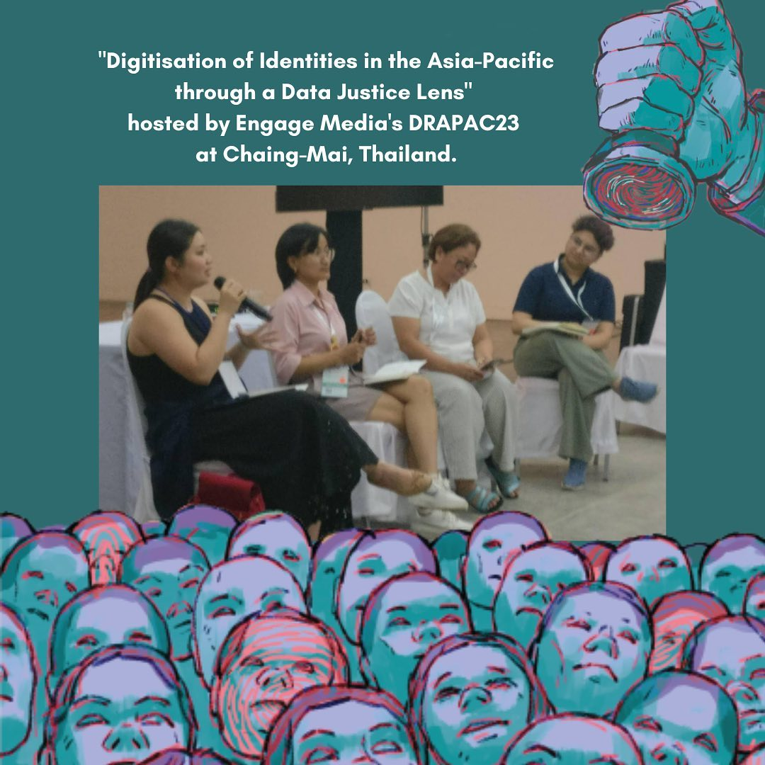

Figure 15 Photo of the event, "Digitisation of Identities in the Asia-Pacific through a Data Justice Lens" hosted by Engage Media's DRAPAC23 at Chaing-Mai, Bangkok.

## Bill Hackathon: Information Technology Bill, 2075(Draft)

The Nepal Association of Software & IT Services Companies (NASIT), in collaboration with the Ministry of Parliament and Ms. Sumana Shrestha, recently hosted an IT Bill Hackathon. Our organization was invited to participate and provide a gendered perspective on the proposed legislation.

Body & Data team, delivered a presentation that analyzed and addressed critical issues within the IT Bill. The focus was on the use of unclear terminology and potentially unfair or biased languages in the IT Bill. A feminist lens is required to reframe the bill, so the team advocated for a clearer definitions of concepts like obscenity, personal data, and malicious intent. Additionally, concerns regarding data misuse, information breaches in foreign territories, inconsistencies between the proposed IT Bill and existing privacy act punishments, and the importance of informed consent were also highlighted by the team.

# Movement Building

At Body & Data, movement building is central to our mission; through collaboration with like-minded organizations, we amplify our voices, share resources, and drive lasting change. We're especially grateful for the partnerships and contributions of some of our fellow organizations, and groups in advocating for digital rights.

Some highlights include national events like "My Body, My Rights" at the Feminist Forum 2023, where we presented a paper on Data Privacy in Nepal. Additionally, we presented on "Digital Identity as a Foundational Anchor" at the Digital Conclave 2023. Our national collaborations also included a Digital Security Workshop conducted alongside Change Action Nepal, Himal Fellowship, and NIDWAN.

On the international front, Body & Data presented a paper on Legal Tech application and access to justice in Nepal at the Access to Justice Conference by Tilburg University. We further strengthened international solidarity by facilitating the APC's FTX program and the Digital Security Workshop for Bangladesh WGG partners.