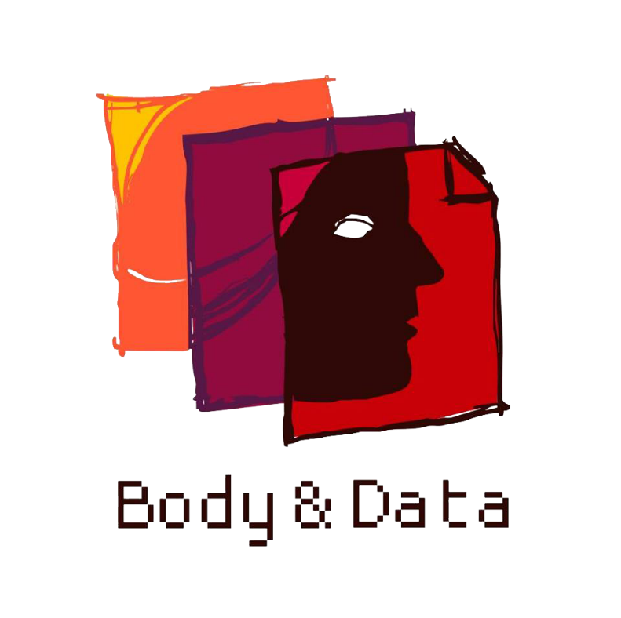
ANNUAL REPORT
2022

Thank You Note
2022 was a year of self reflection and hard work for us, where we were motivated to make changes, understand the changing political scope of our work, bring clarity to our values as an organization. We were able to find ourselves being more confident and prioritize our community that we work with. The credit goes to our team, friends, ally organizations and individuals who have cheered and affirmed us throughout this year.
Thank you to our core team of Rita Baramu, Kabita Rai, Youba Rai, Neha Gauchan, Shripa Pradhan. We would also like to thank Sapana Sanjeevani and Sj for being together with us during this journey. Thank you to Reena Prajapati for making home of our office. We would like to thank Pras for your contribution through your internship. A special thank you to our board members Supriya Manandhar, Bharat Shrestha, Sarita Lamichhane and Pallavi Payal for their much needed guidance and support. We would also like to welcome our new board member Gauri Nepali on the team!
We would like to thank Mahima Pradhan, Yesung Rai, Bhaskar Gautam, Nuva Rai, Anuska Sthapit, Kailash Rai, Sukriti Manandhar, Babita Rai, Forest, Sareena Rai, Pradeep Gurung, Bibhu Luitel, Erica Diya Basu for working with us in various projects as consultants, field officers, translators, illustrators, video editors and resource persons this year. Thank you to all the supporters and well wishers for encouraging and motivating us. We hope to continue and flourish our advocacy in the future with your support!
Shubha Kayastha
Co-founder/ Executive Director

Contents
About Us 1
Our Vision 1
Our Mission 1
Our Goals 1
Strategic Objective 2
Production of Knowledge of Digital Rights 3
Research report on ‘Digitization of Identity in Nepal: Efforts, experiences and effects’ 3
Digital Rights in Nepal: Media Monitoring Report 2022 3
Digital Rights Content from our Community 3
Facilitation of Information and Knowledge on Digital Rights 5
Feminist Tech Exchange 5
Kathkaa Kura: Digital Storytelling Workshop 6
Intersecting Digital Rights Issues and Movements 6
Advocacy and Campaigns 7
Petition to the Election Commission on Right to Privacy & Data Privacy at Times of Election 7
Testimonies on Privacy and Data Privacy in Nepal 8
Internet Swatantrataa Sambad (Conversations around Internet Freedom) 8
Research Dissemination: Mapping Laws Relevant to Online Violence in Nepal 9
Expansion of Digital Rights Conversation with Community Radios in Gandaki Province 10
Internet Boundaries and Beyond: A Multi-Media Project by Shubha Kayastha and Deepti Silwal 10
Forums and Affiliation 11
Buildings Nurturing Frameworks 12

About Us
Body & Data was established in 2017 with the goal of marginalized groups being able to exercise their rights in a safe and just digital space. We work for enhanced understanding and access to information on digital rights among women, queer people, marginalized groups and stakeholders in context of Nepal.
In our 5th year of working in digital rights in Nepal, we focused on broadening discourse and producing knowledge on digital rights through an intersectional feminist lens. We worked towards building a community of individuals from marginalized groups who are meaningfully participating in digital spaces.
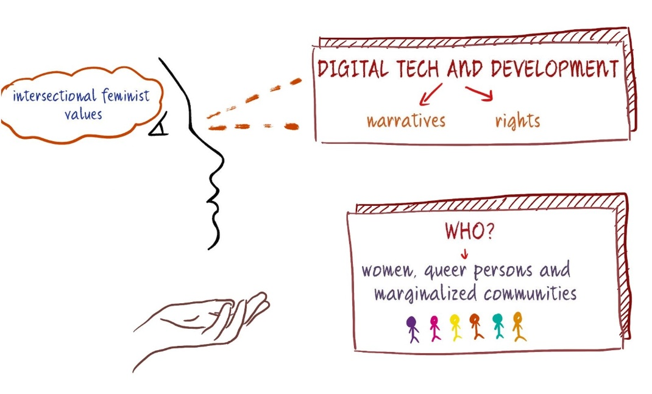

Our Vision
Accessible, safe and just digital space for all.

Our Mission
We advocate, campaign and adopt suitable strategies to ensure accessible, just & safe digital space for marginalized people.

Our Goals
Enhanced understanding and access to information on digital rights among women, queer people, marginalized communities and stakeholders.
Women, queer people and minority groups are able to exercise their rights in a safe and just digital space.

Strategic Objective
- Cross movement building among relevant civil society movements through dialogue, advocacy and collaboration.
- Knowledge building and dissemination on digital rights in context of Nepal through consultations, research, workshops/capacity building and outreach.
- Facilitation for access to information and knowledge, and learning of women, queer people and minority groups on digital rights through building space and outreach

Production of Knowledge of Digital Rights

Research report on ‘Digitization of Identity in Nepal: Efforts, experiences and effects’

Body & Data has been researching the digital space against the overarching mission and vision of digital rights for individuals with particular emphasis on marginalized and vulnerable communities. Studying Nepal’s National ID Card, especially from an end-user perspective, fell well within the ambit of our objectives. This pilot study examines premise against Nepal’s National Identity Card (NID).

The use of biometric IDs, beyond simple identity verification and authentication, has the potential to become a near-continuous measurement of people’s everyday lives through the collection, processing, and sharing of their unique bodily data. Their digital rights are often sacrificed against undue surveillance and privacy invasions of presumed technocratic, bureaucratic, and market efficiencies. Additionally, pre-existing marginalized communities are further excluded from political, social, and economic benefits.
Full report releasing soon. Please look out for it

Digital Rights in Nepal: Media Monitoring Report 2022
Monitoring various media articles published around digital rights issues is one of our key activities. This year, the analysis encompassed myriad of subjects - efforts of digitization by the government and its impacts and experiences of marginalized communities, freedom of expression online including sexual freedom and online censorship, conversations around privacy and data privacy in Nepal and surveillance, and technology-based violence in context of Nepal in 2022. Overall, through our media monitoring, we analyzed the matters of marginalized communities in online spaces that has been covered in mainstream media in Nepal, identifying different trends and highlighting the gaps visible therein. The findings of the media monitoring were shared throughout the years through quarterly media monitoring reports in our newsletter and website.
You can read the annual media monitoring here

Digital Rights Content from our Community
We continued to deconstruct what knowledge and knowledge generation means for us in 2022 by engaging with our community and their experiences of digital spaces. This project became a collective documentation of lived realities of women, queer persons, people with disability and other marginalized communities as they resist, engage and live their lives on the internet. Topics around Sexual and Reproductive Health and Rights and its intersection with internet, online violence and discrimination, freedom of expression, sexual pleasure, surveillance and digital accessibility for people with disability were explored together.
- Pras - The Allocishet Vision in Schools: A Digital Perspective
- Jalasa Sapkota - Let’s Strive to Make Our Digital Platforms Accessible for All
- Shailee Chaudhary (Translated into Bhojpuri by Sweetie Chaurasiya) - मधेश में इन्टरनेट पहुँच, डिजिटल अधिकार आ गोपनीयता
- Sano Prayas - कोही किन अश्लील ?
- Babita Rai (Translated into English by Bibhu Luitel) - The meaning of a woman’s sexual expression
- Barsha Baral - नेपालमा नागरिक पत्रकारिताको बृहत्तर परिवेश
- Mahima Pradhan - My Curiosity Led to Discovery – Discovery of Self-Pleasure
- Agrani Thakuri Jha – I am You
- Pooja Bista - Fear of Using a Menstrual Cup

Facilitation of Information and Knowledge on Digital Rights

Feminist Tech Exchange
Feminist Tech Exchange (FTX) is a digital security workshop, that utilizes a unique methodology for building capacities through understanding and sharing emerging digital-related issues while questioning the societal and political aspects of technology through a feminist lens. This year, we expanded Feminist Tech Exchange by engaging with artists and journalists, queer rights activists, disability rights activists and women and queer persons from Gandaki province. We also had a regathering with previous FTX participants. Through engagement with primarily queer persons, women and people with disability, this year we had the opportunity to increase conversations around digital rights with 114 participants.
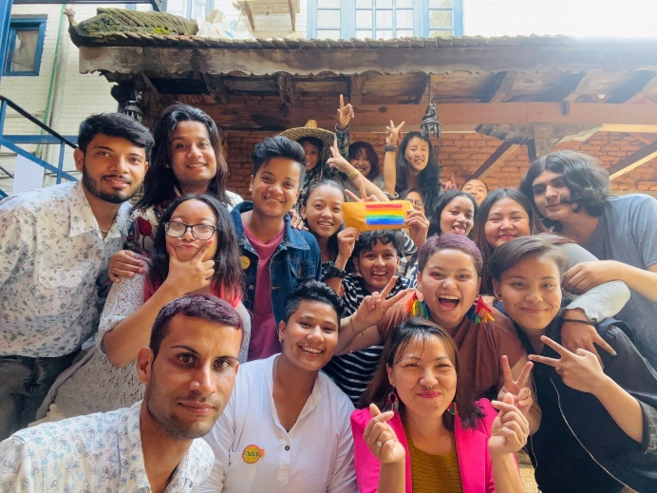

Kathkaa Kura: Digital Storytelling Workshop
KathaKaa Kura is a digital storytelling workshop, that explores powerful individual stories and participants' lived experiences through the use of digital mediums by focusing on the digital security aspects of storytelling. This year, we explored and co-created stories of 15 individuals surrounding digital rights, identity, indigenous heritage, body image, feminism, mental health, personal relationships and reflections.
You can watch the stories from Kathakaa Kura 2022 here.
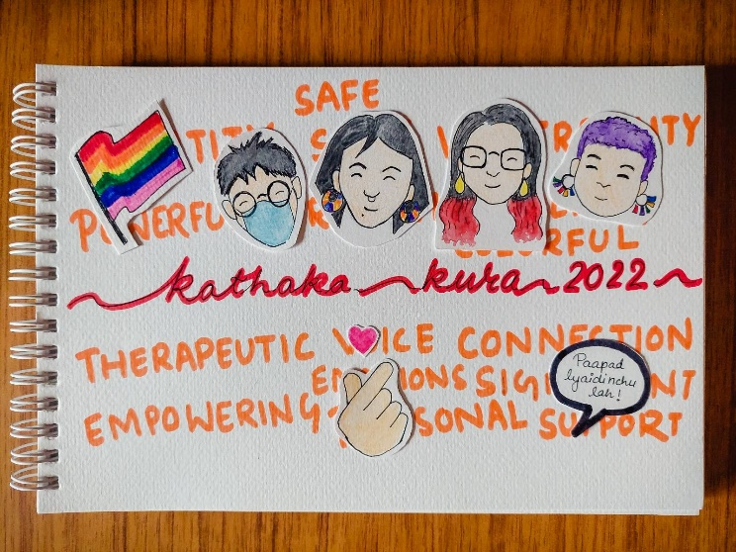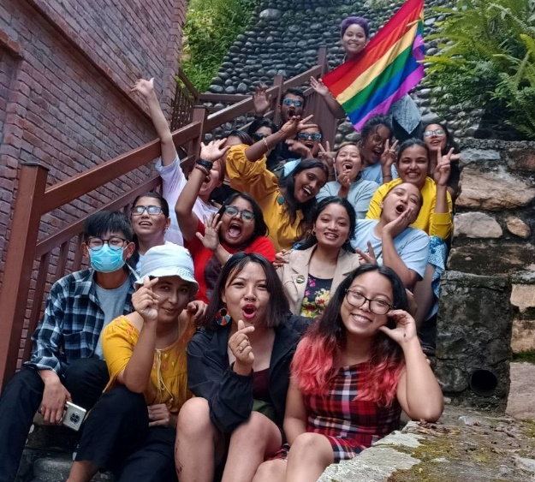

Intersecting Digital Rights Issues and Movements
In 2022, we had the opportunity to intersect issues of digital rights and expand the discourse with various movements, specifically women rights movement, queer rights movement and disability rights movement in Nepal and regionally. We worked with organizations like Voices of Women Media, LOOM Nepal, Asia Pacific Transgender Network, Point of View to build spaces centering around different facets of digital rights, which includes workshops around countering online violence, intersecting digital rights with gender and sexuality, digital security and mental health.
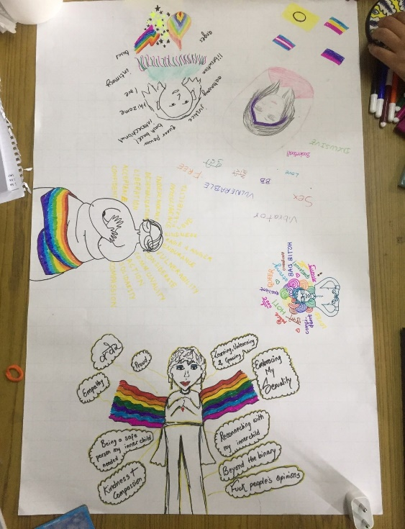

Advocacy and Campaigns

Petition to the Election Commission on Right to Privacy & Data Privacy at Times of Election
While Nepal observed its 2nd local elections, concerns regarding privacy and data privacy of voters were raised when the Election Commission made its database of voters' details publicly available on its website. Such open access to the private information of millions of Nepali people infringes their right to privacy while also putting their information at risk for misuse, theft, targeted surveillance, stalking of marginalized and vulnerable communities and more.
Through the petition circulated nationally and globally, total of 20 international digital rights organizations, 4 national civil society organizations and 1003 Nepali citizens addressed the issue.
Following the signature collection, we along with different human rights activists and civil society members met with the Chief of the Election Commission and handed and submitted the signed petition. The commissioner acknowledged the importance of data privacy and data security of voter’s data but said the commission is not able to take any action against the Electoral rules that requires for the data to be accessible in public.
Advocacy for our right to privacy and data privacy continued in the form of our discussion on “Election in Nepal: Voters’ Privacy Concerns”. Individuals, activists, lawyers and collectives from various backgrounds joined our discussion on the issue of data privacy of voters’ on the surface of upcoming elections among different stakeholders. Matters around role of big tech companies in election voting manipulation, breach of privacy of Nepali voters by political parties and candidates were discussed.
Bhoj Raj Pokharel, former Election Chief Commissioner from Nepal and Shubha Kayastha our Executive Director lead the panel discussion.
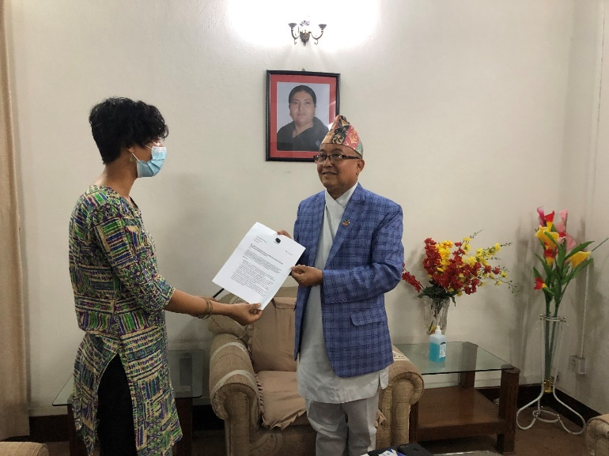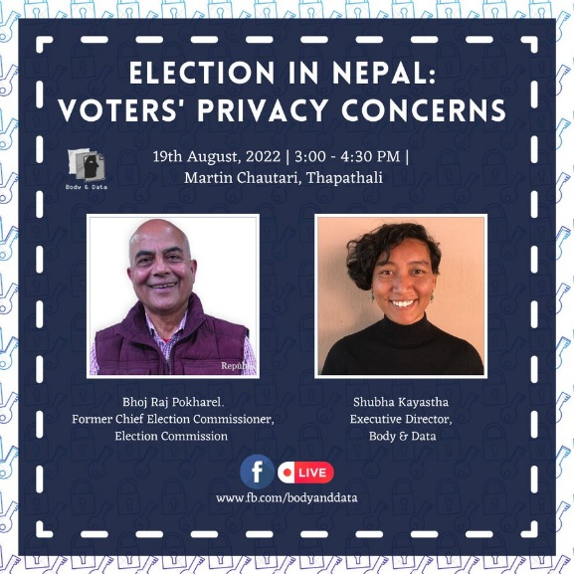

Testimonies on Privacy and Data Privacy in Nepal
Broadening conversations around privacy and data privacy, we had a collective documentation from 9 activists, lawyers, disability rights activists, women rights activists, and other diverse individuals. They shared their concept of privacy and data privacy, its concerns and how it affects their day-day lives was shared widely through our communication channels highlighting the #DataPrivacyMonth in January. The testimonies were collected after a consultation event on Privacy Act 2018 that Body & Data had organized. Through the testimonies speakers critically analyzed the Individual Privacy Act 2018 and its loopholes, through an intersectional lens. The dissemination wrapped up with an illustration that depicted the virtual and lived realities experienced by the marginalized groups where their lives are surveilled and monitored restricting their right to privacy.
You can find the testimonies here

Internet Swatantrataa Sambad (Conversations around Internet Freedom)
Internet Swatantrataa Sambad (Conversations around Internet Freedom) is one of our strategies to increase discourse around digital rights with intersection of varioys issues and nuances within the digital rights framework.
Law graduates, students and lawyers joined our conversation “Dialogue on Laws Relevant to Online Violence" with the collective Paluwa Pleaders. Here, we explored and critically analyzed the present laws that caters to online violence, questioning loopholes, moral policing and censorships within the framework of law.
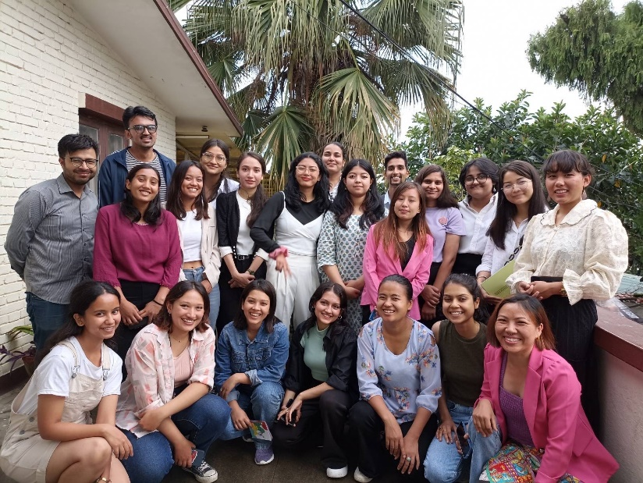

Research Dissemination: Mapping Laws Relevant to Online Violence in Nepal
With the aim to focus on the relevant laws through an intersectional lens, state its positive and problematic aspects in the justice-seeking process for the survivors and find out ways in which the issue can be addressed, we organised a dissemination and discussion event of our research “Mapping Laws Relevant to Online Violence in Nepal”. The event was joined by different women rights groups, lawyers, journalists and individuals interested in digital rights issues. The research report was reviewed by Mohna Ansari: former commissioner of Naional Human Rights Commission, Babita Rai: feminist writer and activist.
You can read the report here.
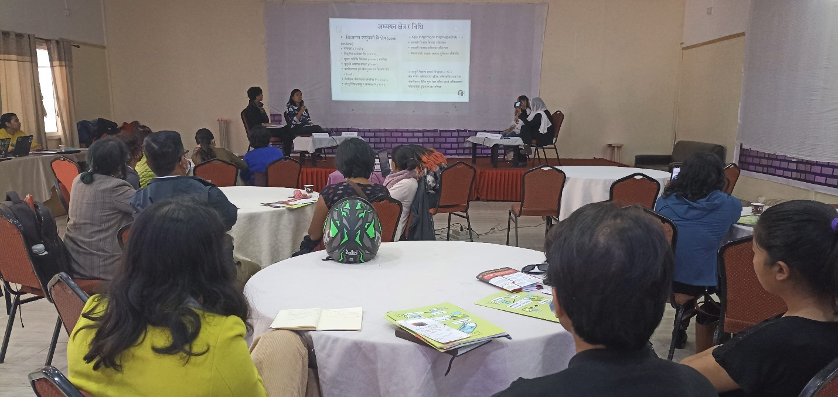

Expansion of Digital Rights Conversation with Community Radios in Gandaki Province

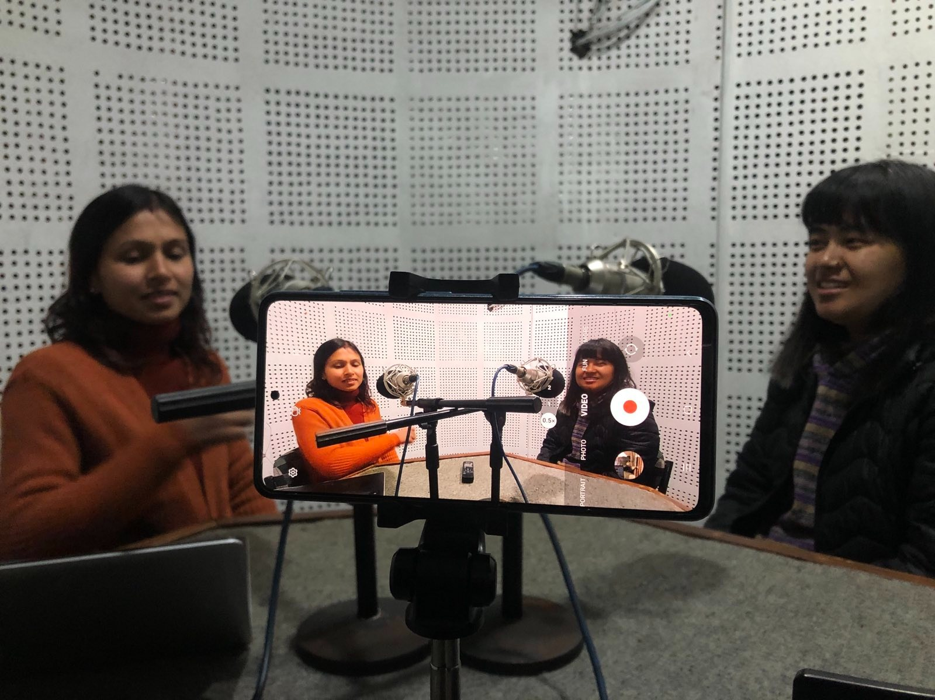
In 2022 and 2023, we aim to broaden digital rights discourse in Gandaki province. We worked with 20 community radios from the province to map the issues and needs of digital rights in local context by organizing preliminary workshops. Through the assessment and contextual understanding of digital, we are now working with the community radios to co-create radio programs directed towards bringing awareness on issues of privacy and data privacy, internet access, privacy breach during local elections, online violence and understanding digital rights.

Internet Boundaries and Beyond: A Multi-Media Project by Shubha Kayastha and Deepti Silwal
In an effort to make conversation on digital rights and the feminist internet more accessible, a multi-media exhibit "Internet Boundaries and Beyond" was curated by Shubha Kayastha from Body & Data, and Deepti Silwal collaboratively with 30 individuals. The 9 art projects as part of the exhibition consisted of poetries, paintings, short animated videos, digital art, puzzle game, etc. Individuals involved explored and imagined an internet that is feminist and intersectional, guided by principles of expression, consent, pleasure, resistance, movement building, privacy & data, among others.
The project was a part of the Kathmandu Triennale 2077, which was exhibited at the Nepal Art Council, Babar Mahal.
Find more about each exhibit here
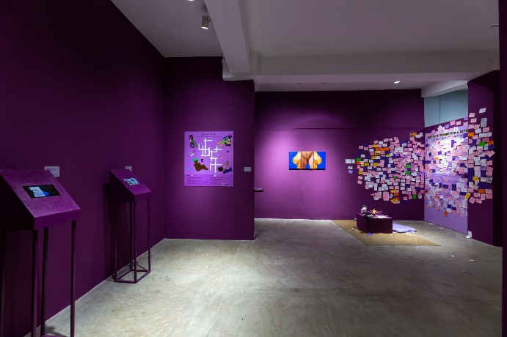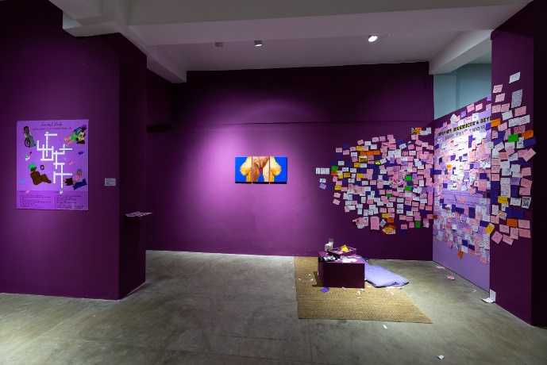

Forums and Affiliation
In the year 2023, we participated and advocated for digital rights through intersectional feminist lens, in various events related to women’s rights, queer rights and digital rights movement regionally and globally.
- Technology-based Gender-Based Violence: Trends and Strategies by Panos and South Asia Check
- Participation at The International Lesbian, Gay, Bisexual, Trans and Intersex Association Asia Conference 2022
- Participation at “Consultation on Digital Accessibility” by Prayatna Nepal
- Paper Presentation titled "Unshackling Expression: Regulation of Freedom of Expression in Nepal” at Chautari Annual Conference 2022
- Session on “Building Bridges: Digital security strategies for women and people of marginalized genders at Rights Con 2022”
- Session on “Gender, Tech and Society: A Feminist Analysis of Digital Rights in Nepal” at MozFest 2022
- Panel discussion on “#BornWithPride: Making Sex-Education Queer Friendly” by Freidrich Naumann Foundation for Freedom (FNF), South Asia
- Participation at Pride Parade 2022

Buildings Nurturing Frameworks
2022 was a year where we got to celebrate, rejoice and reflect as a team. Times seemed to be going extremely fast, because looking back now, there still was remnants of covid lockdowns in the earlier months of the year. We want to remember our 5th anniversary virtual celebration where our community and loved ones came together with their teas and colors.
Chitwan and its nature and peace became a place where we got to plan for 2022, assess our work and team effort and celebrate each other. With the new Annual General Meeting, a new team of board members lead the organization!
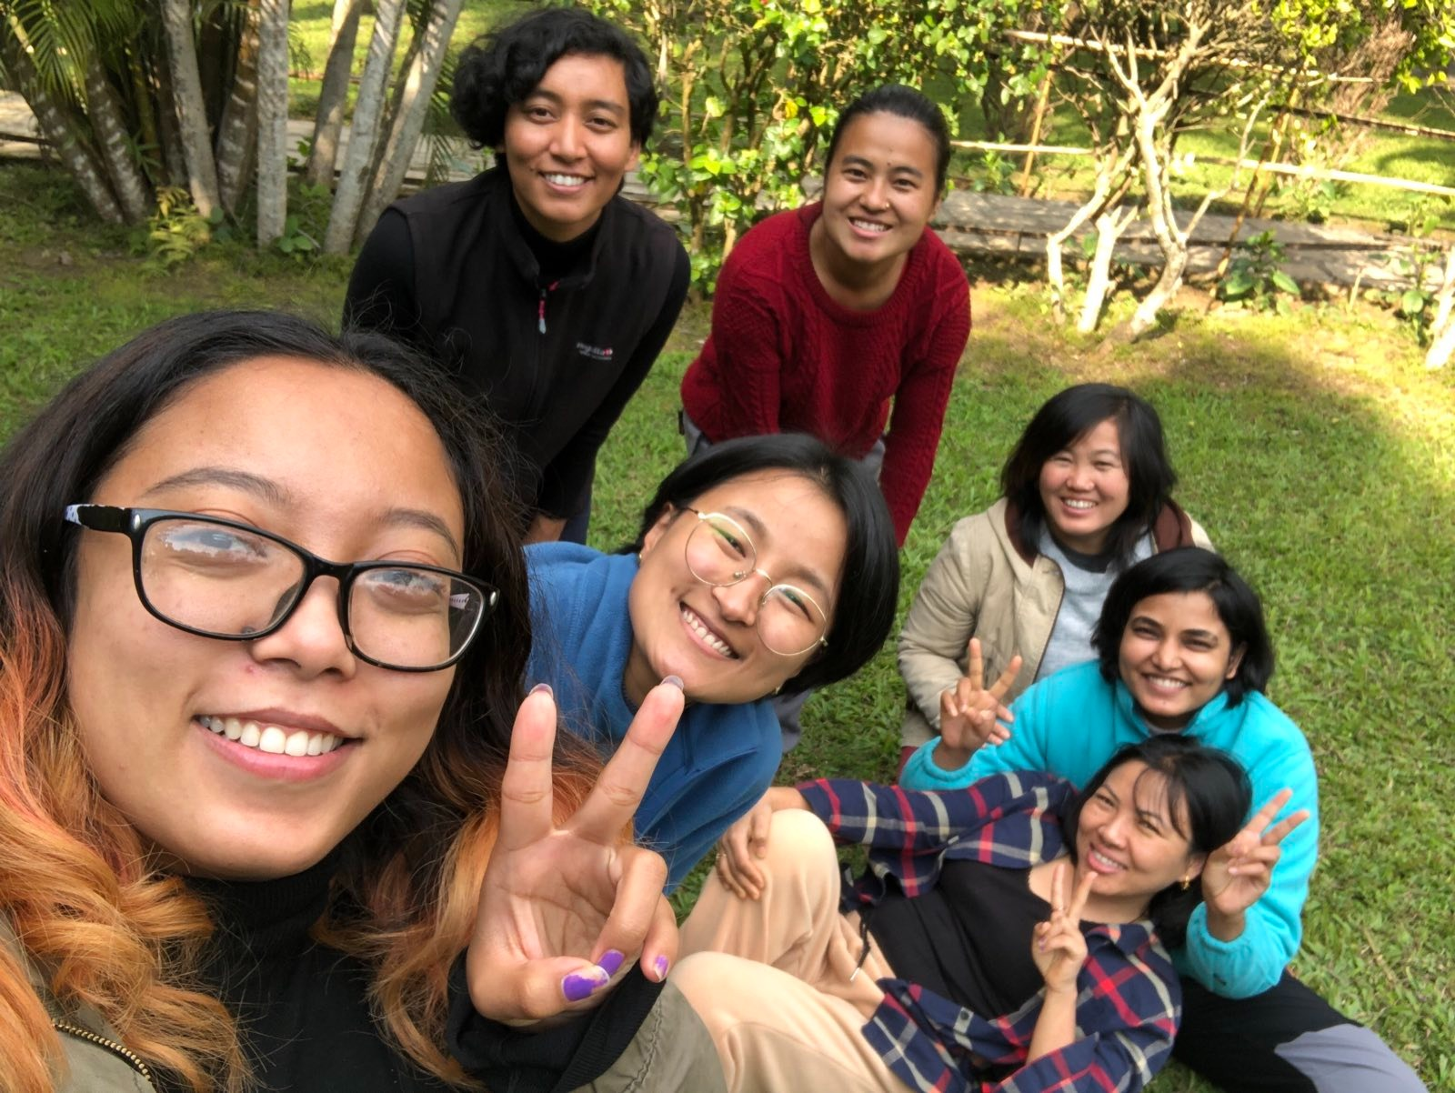
Our organizational survey helped us to connect and hear our community and audiences more. It reaffirmed our values, gave confidence in our advocacy and helped us set our goals for 2023. We are now moving forward to 2023, with clarity in our minds about our objectives, aspirations for new scope of our work and a larger team!

bodyanddata.org
Facebook | Twitter | Instagram
@bodyanddata

