Annual Report 2021
Body & Data

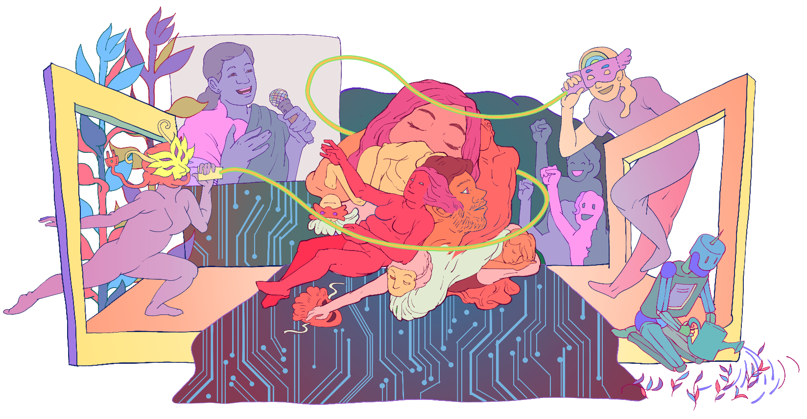

Table of Content
Introduction 1
Knowledge Generation 2
Engagement through Online Campaigns and Advocacy 6
Constituency Building 9
Cross Movement Collaborations 11
Forums and Affiliations 14
Website and Newsletter 16
Publications 17
Media 17
Articles: 18

THANK YOU
2021 was a transformational year for us, where we got to reflect our own values as an organization as well as further enhance our work. This would not have been possible without our team, friends, ally organizations and people who have supported us throughout this year.
Thank you to our core team of Rita Baramu, Kabita Rai, Youba Rai and Shripa Pradhan. Having Sapana Sanjeevani and Neha Gauchan joining the team helped us expand and explore our work into new horizons even further this year. Thank you to Reena Prajapati for helping us in the office, and thank you to Mahima Pradhan for your hard work and proactive engagement as the intern. We would also like to thank our board members Supriya Manandhar, Bharat Shrestha, Dovan Rai, Sarita Lamichhane and Pallavi Payal for their much-needed guidance and support.
We would like to thank Pramila Shrestha, Yozana Magar, Arpana Shrestha, Anuska Sthapit, Diya Basu, Amina Singh, Kailash Rai, Sukriti Manandhar, Sabrina Dangol, Yesung Rai, Pranika Koyu, Babita Rai, Mrigaja Bajracharya, Sareena Rai, Pradeep Gurung, Bibhu Luitel and Ashu Sarraf for working with us as staff members, consultants, translators, researchers, illustrators, video editors and resource persons for various events and workshops this year.

Shubha Kayastha
Co-founder/ Executive Director

Introduction

Established in 2017, Body & Data works to enhance understanding and access to information on digital rights among women, queer people and marginalized groups where they are able to exercise their rights in a safe and just digital space. We work towards the vision of accessible, safe and just digital space for all, through cross movement building, facilitation for access to information, knowledge building and dissemination on digital rights in the context of Nepal.
Understanding our objective on broadening discourse on digital rights through intersectional feminist lens, we carried our activities under knowledge generation on digital rights, facilitation for access to information and knowledge on the issues of digital rights and building community of women, queer persons and other marginalized groups through cross movement collaborations.
2021 was a year of introspection of what our organization stands for and the purpose behind the work we are doing. It was also a hopeful year where we created visions of what world we want to be a part of and where our organization fits in that vision. Furthermore, it was a year where our intentions and objectives behind our work was clearer and our enthusiasm for our work has increased.
As we reflect back on our activities of 2021, we want to acknowledge the communities we work with, ally organizations and movements and individuals who have cheered us, advised us and worked with us.
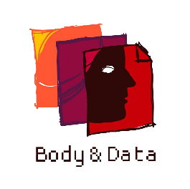

Knowledge Generation

Production and dissemination of knowledge on digital rights from an intersectional feminist lens is an integral part of our work. In 2021, we continued our work in doing research on various issues of digital rights and produced research reports. Moreover, broadening and deconstructing what knowledge means to us, we also collaborated with many independent content creators and localized already available resources around digital rights. In every content we generated, bringing the intersectional feminist lens is intertwined.
Research on Digital ID Card
In 2021, we launched research on biometrics national digital ID card in Nepal. The study aims to unpack the narratives regarding digital privacy, nationality, national policies and developmental aspects that goes around the digital ID card and initiate the discourse from human and digital rights perspective in the Nepali context. The first phase of the research has been completed and the dissemination of the research will be done in 2022.
Localization of Feminist Principles of the Internet
Feminist Principles of the Internet is one of our guiding documents and values as we navigate our online spaces and work as a digital rights organization. This year, we localized and translated the same feminist principles of the internet, which was originally produced by Association for Progressive Communications for the community that we work with. Contextualizing the principles and publishing it is one of our goals in the coming year.
Working with Independent Content Creators
We focused on deconstructing what knowledge means for us in 2021. Our research has always been a part of the knowledge around digital rights in Nepal. Beyond that, we explored the rich experiences of the community we work with – through their written piece, poems and more creative ways. Through the works of our community members, we got to explore what knowledge building of digital rights in Nepal would look like. We worked with 15 independent creators to publish their work ranging from articles, visual poetry, illustrations, etc. related to gender, sexuality, mental health, gender-based violence, digital journalism and digital rights in context of Nepal.
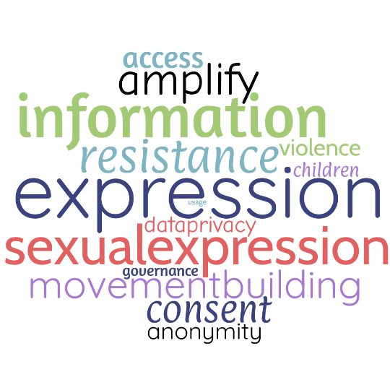
It was our pleasure in co-creating a space for these wonderful content creators and their vast knowledge on digital rights and online experiences
- Babita Rai - महिलाको यौनिक अभिव्यक्तिको अर्थ
- Nuva Rai – I am still learning
- Rita Baramu - डिजिटल संसारमा हाम्रो अधिकार
- Shrijya Thapa – Sexy is Beautiful
- miira – Pleasure Corners of the Internet
- Shubha Kayastha - इन्टरनेटसम्बन्धी मिथ्या ज्ञान
- Rita Baramu - अभिव्यक्ति स्वतन्त्रता र सीमान्तीकृत
- Rita Baramu - यौनिक अभिव्यक्तिमाथि नियन्त्रण किन?
- Shubha Kayastha – Digital Debacles
- Gulabi Samwaad - यौन तथा प्रजनन स्वास्थ्यबारे डिजिटल छलफलको एक प्रयास
- Shuvangi Khadka – Expose, visual poetry
- Barsha Baral – Nuances of Digital Citizen Journalism in Nepal
- MARI: Who Runs the Internet?
- Rukshana Kapali - Body, Society & Tech: Dating as a Trans Woman in Nepal
- Dikshya Khadgi - F for Fandom, F for Feminist Space
- Shailee Chaudhary - Internet Access, Digital Rights and Privacy in Madhesh
- edamame – Look at me now
- Kabita Bahing - इन्टरनेटलाई नयाँ हाउगुजी नबनाऔं
- Bichen – Less of who I am?
- Rimsongma – Beyond just internet

Internet Swotantrataa Samwaad (Conversations around Internet Freedom)
Throughout the year of 2021, we organized many virtual discussions under the name of "Internet Swotantrataa Samwaad" (Conversation for Internet Freedom) and held seven public discussions on various issues. We covered topics around Social Media Management Directive (draft) 2021, Information Technology Bill 2018 and Privacy Act 2018, consultation on Privacy Act, screening and conversations around stories produced at Digital Storytelling Workshop, Feminist Perspective on Data, Diverse Identities Experiencing the Internet and Freedom from Violence.
We had speakers Sulochana Khanal from Women Rehabilitiation Center (WOREC), Dovan Rai from Global Institute of Interdisciplinary Studies, Shreyasha Paudel from NAAMII, Safal Lama (Queer Disability Rights Activist), Zion Magar from Blow of Dark, Yesung Rai (Artist), Deepsh Shrestha (Non Binary Artist), Pratiik Thapa from LOOM, Dipesh Khanal (Queer Rights Activist), Forest (Queer Artist), Resham Neupane (LGBTI Rights Activist), along with various activists and personnel from different background and movements and in-house members of the team for various events in Internet Swotantrataa Samwaad.
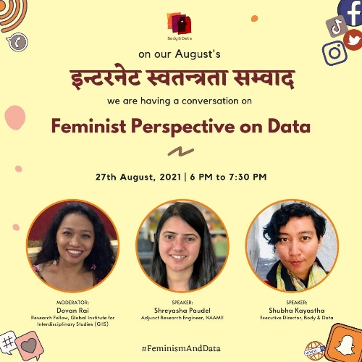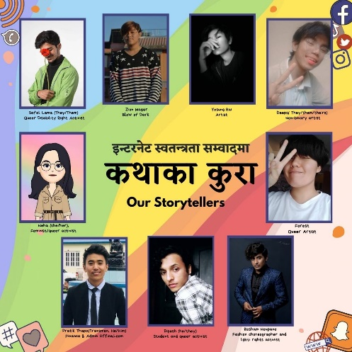

Media Monitoring
From early 2021, we started media monitoring on issues surrounding digital rights where we mapped out numbers of news sources and articles around digital rights in context of Nepal. This helped us to find out common trends, risks and opportunities around digital rights in Nepal which was helpful to set our organizational position and plan our activities plan in accordance to status quo of digital rights in Nepal. The collected information was analyzed and published quarterly.

Dissemination of past research papers
We disseminated the findings and analysis of the research that we worked in the past few years through online mediums. Physical copies were shared with different civil societies and activists working around women’s rights, queer rights, disability rights and other human rights issues. We disseminated the findings and analysis of the research that we worked in the past few years through online mediums. Physical copies were shared with different civil societies and activists working around women’s rights, queer rights, disability rights and other human rights issues. Our main objective of the dissemination was to create more access to the resources and amplify stories of people that were collected through the research process among our community and audience. We disseminated the above-mentioned research reports this year.
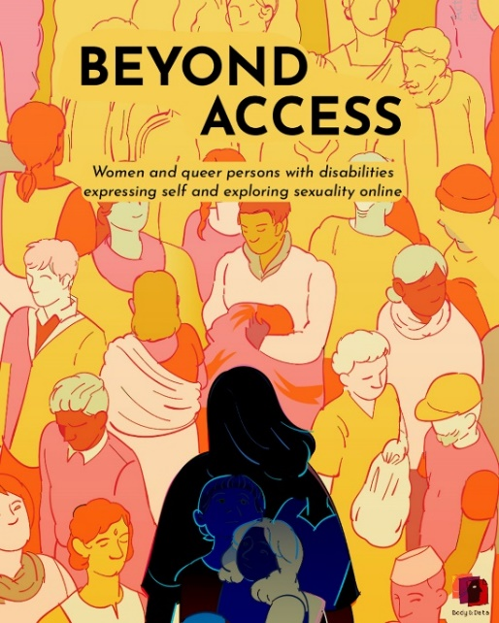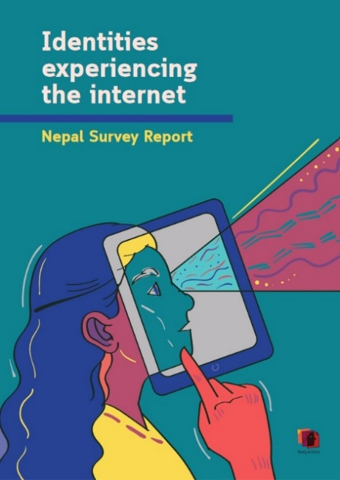
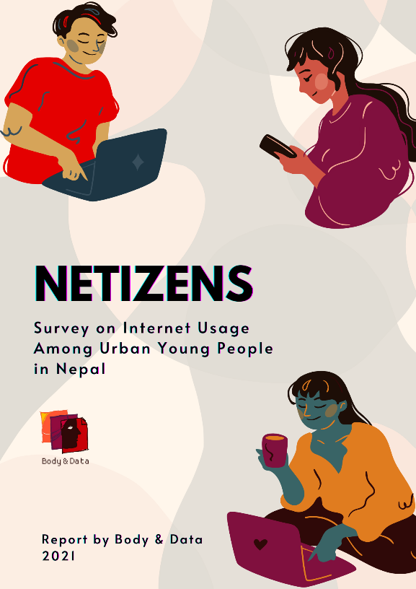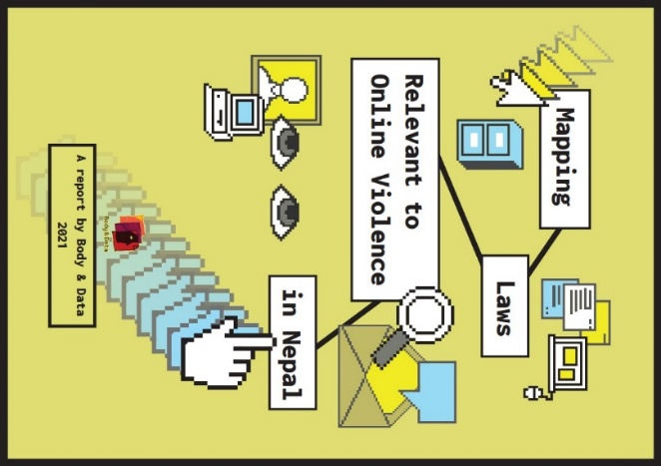

Engagement through Online Campaigns and Advocacy
Through online campaigns and advocacy, we broadened the discourse on digital rights while bringing intersectional perspective. This year, our focus was conversations around digital privacy and online violence as well as bringing attention to contemporary issues around digital rights. For this, we used our online social media platforms along with newsletter to bring attention to the digital spaces we are all part of.
Privacy Campaign
We launched a campaign on Data Privacy Day called #PoliticallyPrivate and #गोपनियताकोगफ where we explored what digital privacy means to young women, queer folks, trans and intersex people, and women with a disability and understand their privacy concerns online and offline. Furthermore, we also amplified various laws that is relevant to privacy and the criticisms of the said laws and policies.
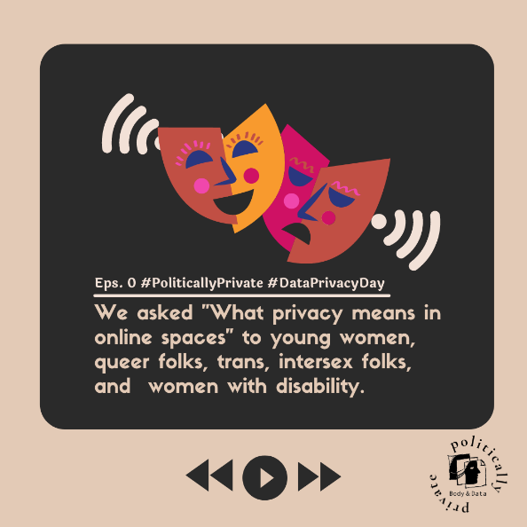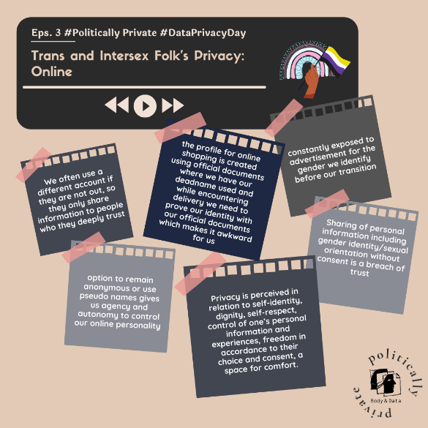

Social Media Management Directive (draft), 2021
As a response to Nepal government’s regressive guideline on online activities of Nepali people which was named as “Social Media Management Directive”, we launched a campaign addressing it. Through twitter threads, memes and virtual discussion, to explore the problems of the directive and its effects on marginalized communities.
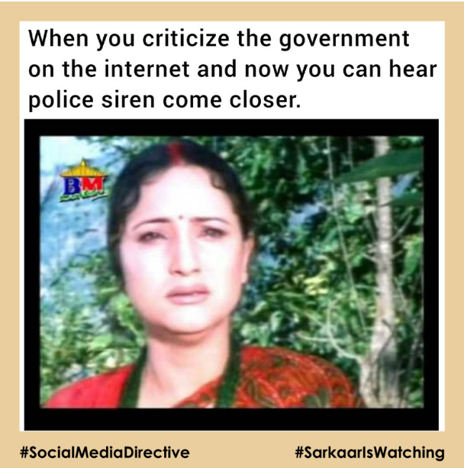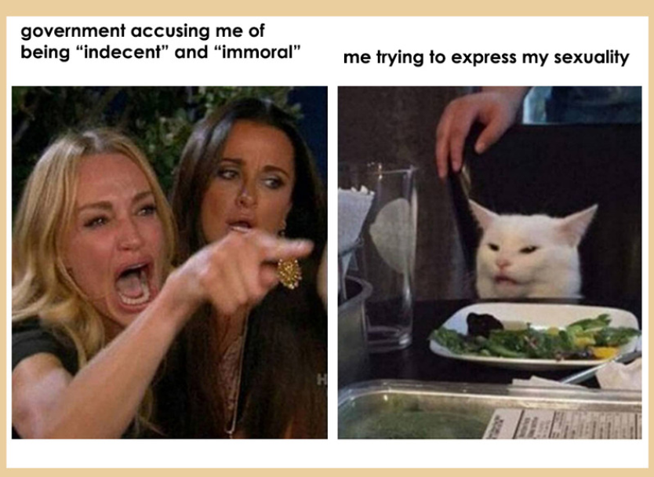
Consultation on Information Technology Bill 2019 and Privacy Act 2018
With the aim to discuss and analyze the IT bill and Individual Privacy Act from a diverse lens, and to create conversations through public and policy advocacy, two stakeholders’ consultations were conducted. Different stakeholders such as activists, journalists, legal practitioner, individuals or organization representatives working with civil society organizations focused on digital rights, human rights, women rights, participated in the events to discuss issues of free speech, freedom of expression and privacy through an intersectional feminist lens while being based on the legislations.
Campaign against Online Violence in Nepal (16 days of activism against online gender-based violence)
As a part of the 16 days of activism against gender-based violence, this year, we published our report on Mapping Online Gender Based Violence which analyzed various relevant laws of our online world. We also amplified various types of violence that can take place in our online world along with having an online discussion event called “Internet Samwaad on Freedom from Violence” where we reflected how freedom from violence looks like in offline and online spaces in collaboration with (Women’s Rehabilitation Center) WOREC.
Statements on Contemporary Issues of Digital Rights and Its Intersections
Digital rights are often seen as standalone and exclusive to people who are online. This year, we tried to show the intersections of digital rights with other human rights issues. We expanded conversations around freedom of expression, surveillance and censorship, caste-based discrimination, discriminatory citizenship policies, harassment towards many activists from marginalized communities, systemic problems and defending various trends that showcase women’s bodily autonomy and sexual expression of people and its intersections with digital rights In Nepal. Through four statements of support and engagement in conversations, we showcased how the problems of online world and offline world are reflections of each other and stems from a larger systemic problem.
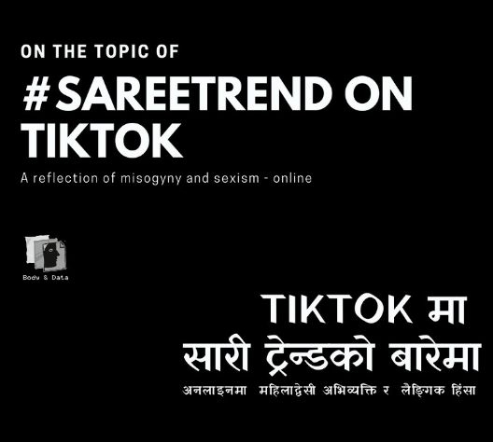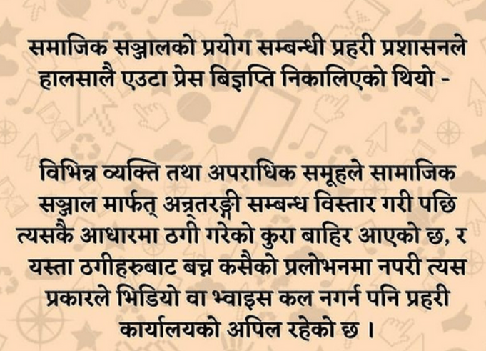

Constituency Building
Through workshops, we want to help build a community of informed individuals who are meaningfully participating and engaging in digital spaces. This year, we focused our workshops and engagement with women, queer people, and people from Madhesh. In addition to working with individuals, this year, we also organized organization digital security workshop with three organizations.
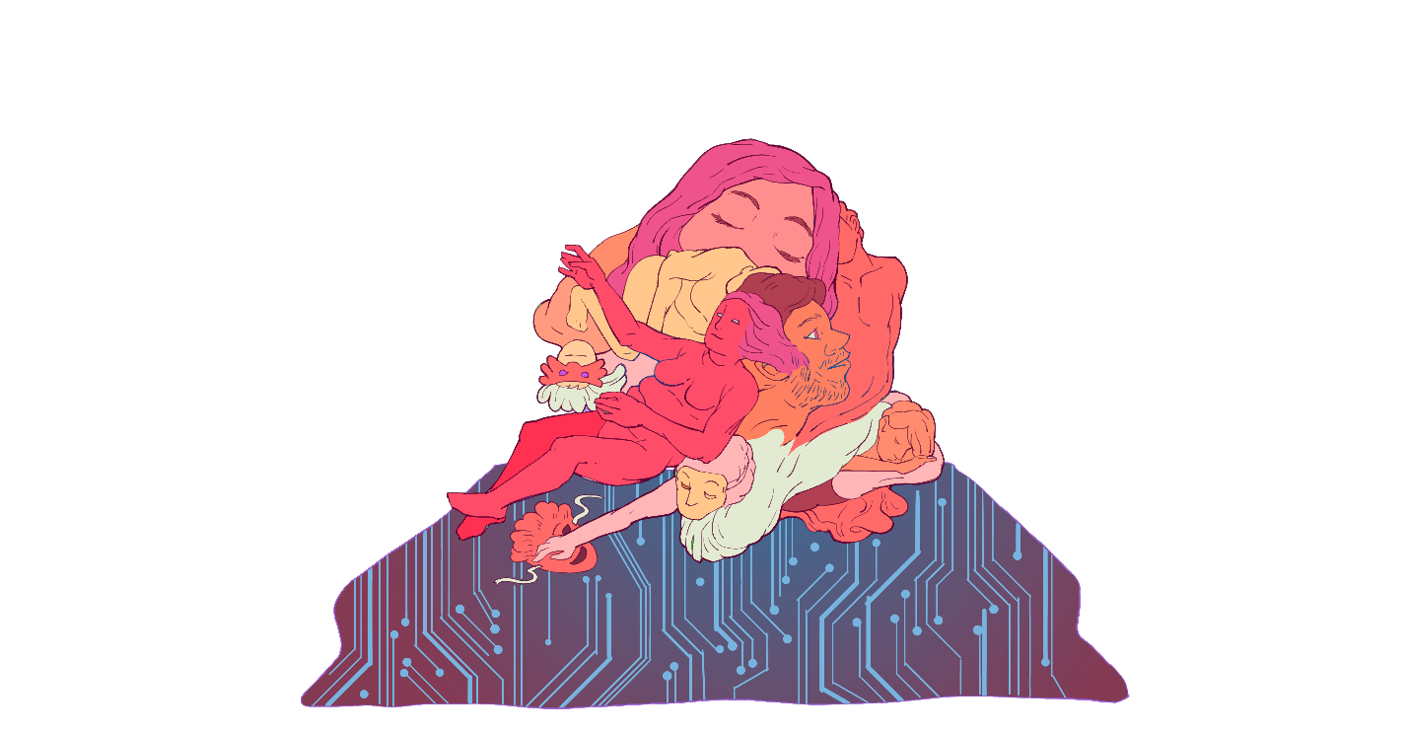
Feminist Tech Exchange: Digital Security Workshop
Feminist Tech Exchange - Digital Security Workshop is one of our key activities to broaden conversation around digital rights and bring hands-on trainings around digital security tools. This year, we did three FTX workshops with different communities – women, queer people and young people from Madhesh. FTX Madhesh was the first FTX we did that we decentralized from Kathmandu and a rich learning experience where we got to understand more about the issues of access, censorship, surveillance and online violence that is unique to Madhesh community.
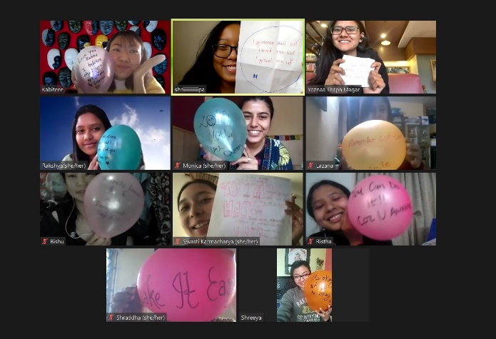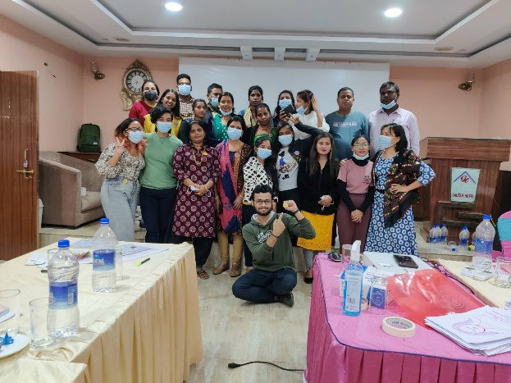
Kathakaa Kura: Digital Storytelling Workshop
Kathakaa Kura: Digital Storytelling Workshop is a workshop that brings together the stories of the community that we work with – women and queer people through digital medium and interlinking the digital security techniques in digital storytelling. This year, the workshop was held online, but was treated with care and warmth from all the participants. At Body & Data, we believe that showcasing stories of diverse individuals, including those from marginalized groups contribute to the goal of making individuals with diverse identities to be visible in the online spaces by making their stories alive and creating an audience to further bring multiple intersectional narratives
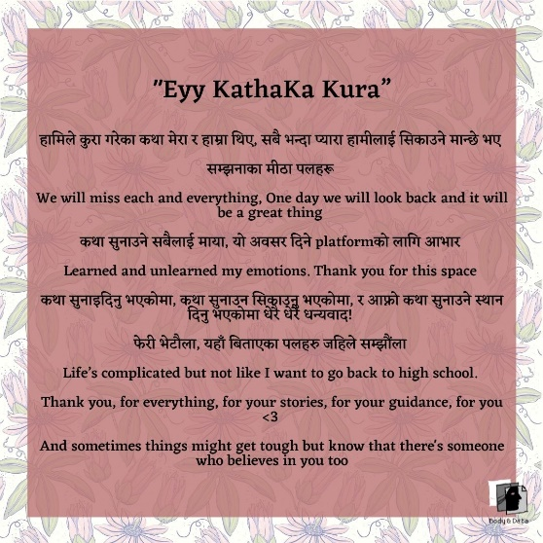

Organizational Digital Security Support
As a part of our work bringing intersections of various movements with digital rights movement, this year we explored the needs and methods of digital security that is unique to activists and organizations of various movements. This year, we had the opportunity to co-create a space to understand digital and physical risks and mitigation of the said risks with organizations working for women with disability, women affected by conflict, female sex workers, women working in entertainment sectors, and activists who are working in grassroot level.
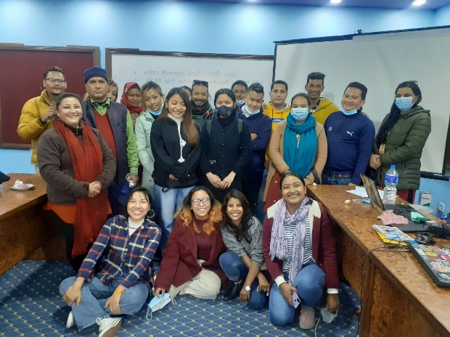

Cross Movement Collaborations
One of our working approaches is understanding that digital rights is an intersectional and cross-movement issue. For this, we collaborated and worked with rights movement that advocate for marginalized groups either through organizing various training programs, one-day session, online collaborations and consultative works.
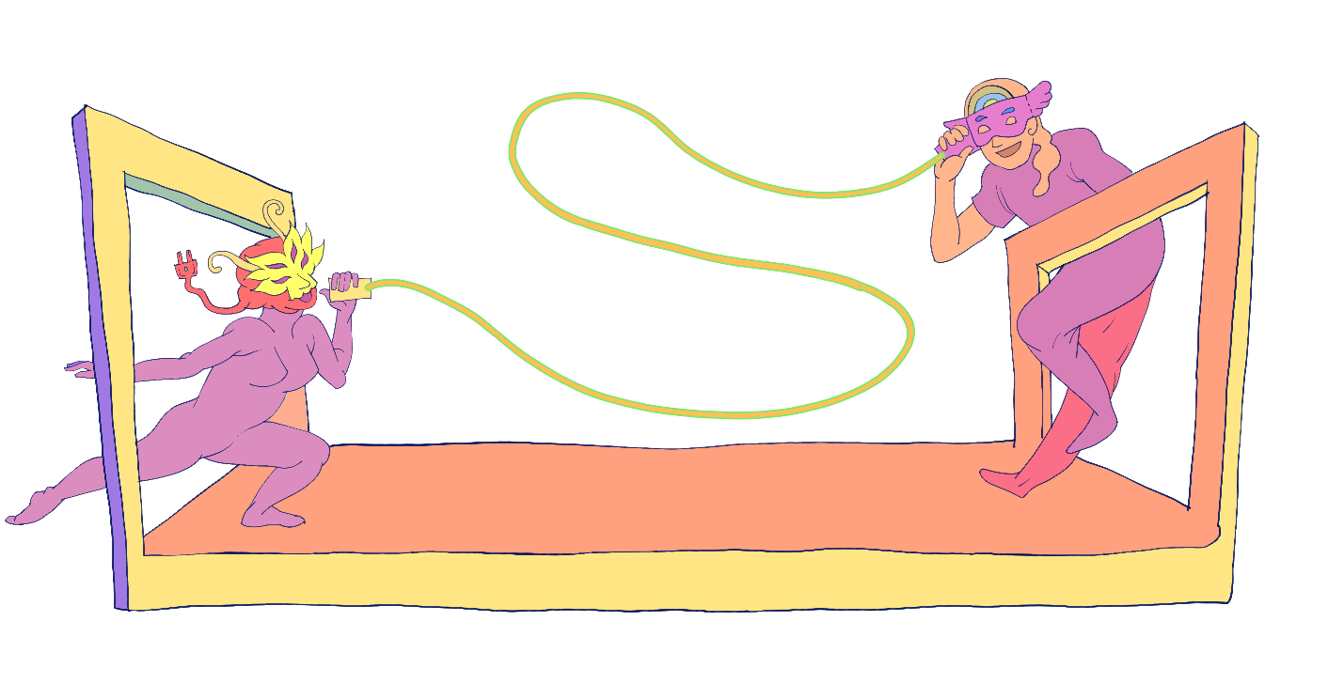

Cross Movement Collaborations in National Level
Discussion on Privacy in Digital World: We organized a virtual discussion on " Privacy in Digital World" in collaboration with Martin Chautari where Rita Baramu from our team spoke on the issue of privacy and surveillance in digital world. The conversation assessed the surveillance through three levels – in families and societies, in government and finally in tech corporations’ level.

Webinar on Creating Feminist Internet: We organized a virtual webinar on "Creating Feminist Internet" in collaboration with Martin Chautari where speakers Supriya Manadar, Sarita Lamichanne, and Pallavi Payal along with the moderator Shubha Kayastha spoke on their lived reality on online spaces along with the opportunities, challenges brought by these spaces and how it could be made more accessible, safe and just.
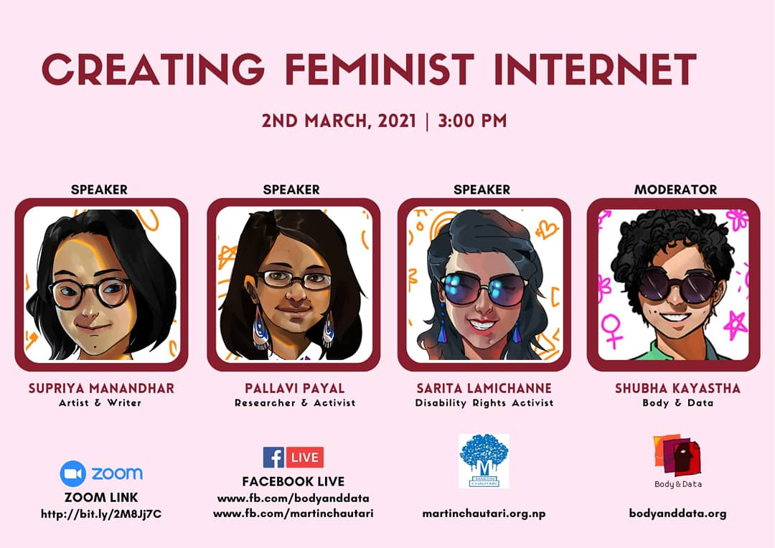

Content on A Guide to Safer Internet Maya: As a collaboration with Kanchi ko Awaj, we created a “A Guide to Safer Internet Maya” which was a guide for practicing safer and private sexting behaviors, showcasing some digital security practices along with safer and private platforms for sexual expression.
Content on Internet: Samajko Aina (Internet: A Mirror of Society): We collaborated with Hatemalo Collective Festival an initiative by indigenous and Dalit rights activists where we produced a video entitle Internet: Samajko aina ( Internet: a mirror of society) which explains how women and marginalized community like Dalits have less access to internet yet are more vulnerable to violation of their online rights.
Consultative Work on Draft Bill: We provided our input to a draft bill from privacy angle initiated by Asia Pacific Transgender Network (APTN) a group of lawyers and queer rights activists. The draft bill is prepared for policy advocacy purpose on Gender and sexual identities of queer people in Nepal.
Other collaborations:
- We provided our input to a draft bill from privacy angle initiated by Asia Pacific Transgender Network (APTN).
- In collaboration with Antenna Foundation, we had a two-day workshop on digital security and digital rights with different community-based activists and journalists.
- We conducted a session on internet and sexuality with Prayatna Nepal for women with disability
- We did a one-day session with Visible Impact around the intersectionality of digital rights and sexual rights and reproductive health.
- In collaboration with Women's Rehabilitation Centre (WOREC), we worked with many communities based human rights defenders of different provinces of Nepal around digital rights.

Cross Movement Collaborations in International Level
Session on Feminist Knowledge Production: Deconstructing Knowledge: In Association for Progressive Communication’s Convening, we did a session reflecting on our work with independent content creators while talking with two of our content creators, their online experiences and their intentions behind creating content and knowledge online.
Session on Digital Security: Perspective from the Margins in Asia: At RightsCon 2021, we held a session highlighting the understanding, perspectives concerns, and narratives, story of resistance around digital rights and security from the marginalized community both from professional and personal experiences highlighting the different intersectionality within digital rights and security. Speakers were Rita Baram from Body & Data - Nepal, Shmyla Khan from Digital Rights Foundation - Pakistan and Dhyta Chaturan from Purple Code - Indonesia.
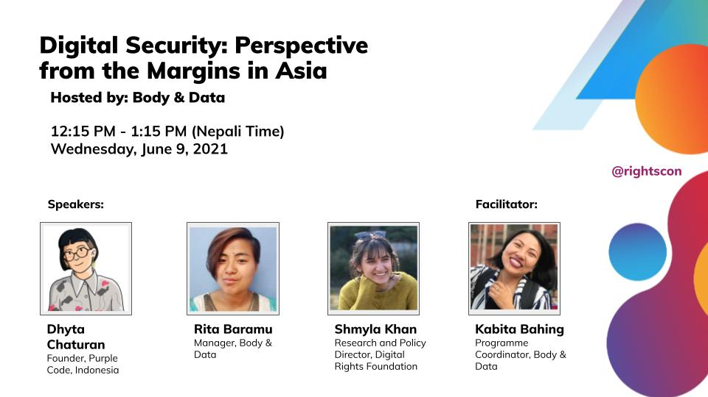
Tweeathon on Internet and Privacy: With Hidden Pockets Collective and Center for Social Research, we collaborated on twitter to bring discussions and attention to various issues surrounding internet, data privacy and what it looks like for marginalized groups as well as Nepal government’s attempts on curtailing people’s right to privacy.
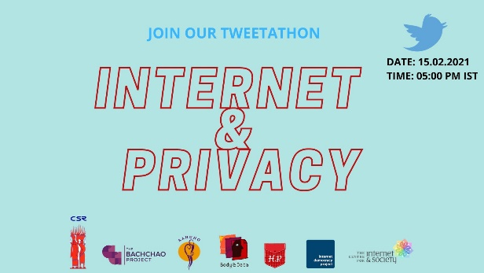

Forums and Affiliations
Apart from our core programmatic activities, we took part in various global, regional and national plenary discussions where we were invited, training programs to better understand issues around digital rights, on gender, sexuality, digital rights and feminist internet.
- Participation at Transgender Pride Parade
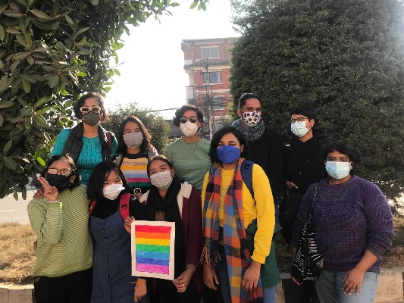
- Sexual Harassment: Prevention and Awareness by Rotaract Club of Patan West
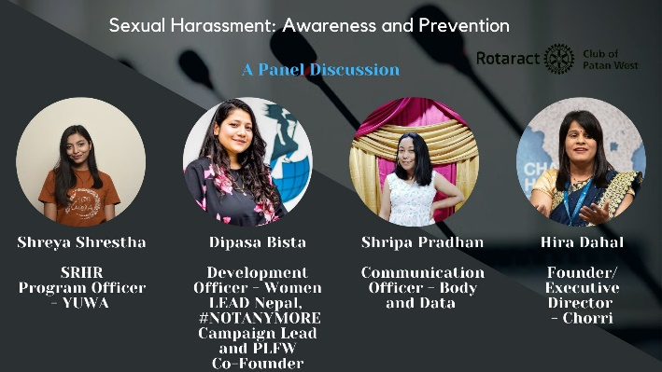
- Transnational Feminist Conversations on Reclaiming Freedom of Expression Online in APRiGF 2021
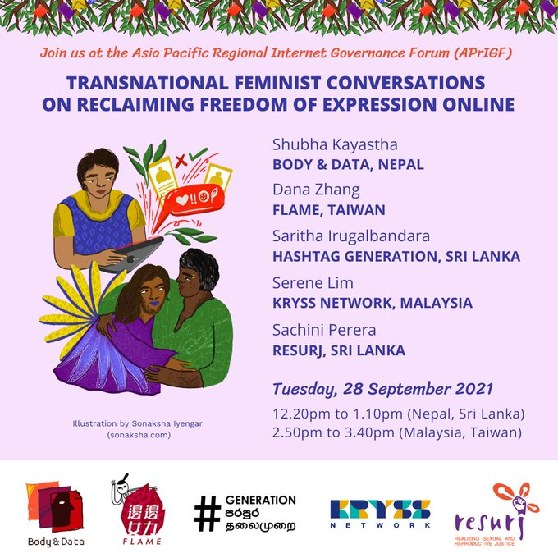
- Session on ‘Global tech inequity and the impact of Silicon Valley’s laissez faire approach abroad’, and ‘Digital gender-based violence in the context of Covid-19’ in RightsCon 2021
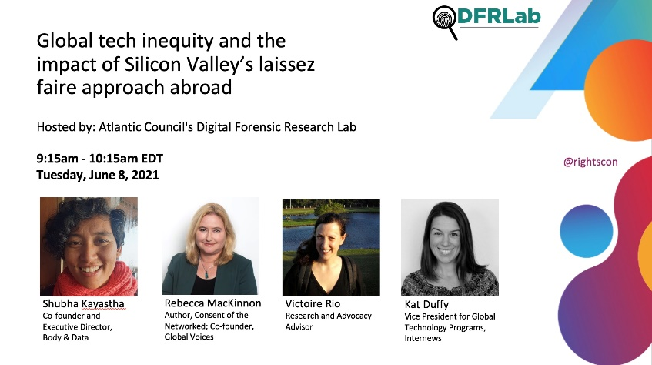
- Tech exchange for safe feminist infrastructure online' by Stolkholm Internet Forum 2021
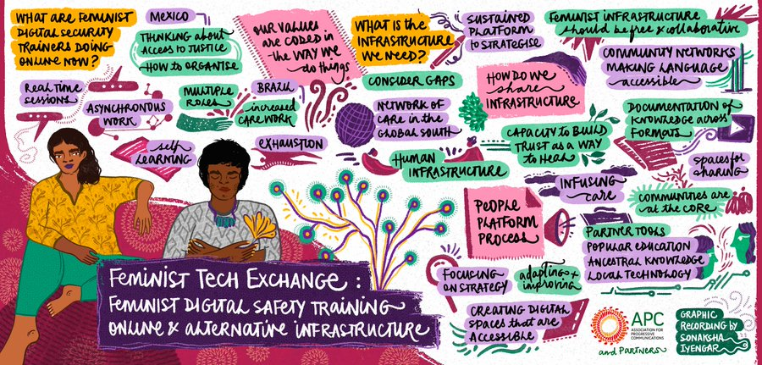
- Lecture on Privacy and Consent in the Digital Age at NAAMI (Naaya Aayam Multi-Disciplinary Institute), Artificial Intelligence Winter School
- Nepal Dialogue Forum Conference 2021, Gender Justice in Nepal by Nepal-Dialog Forum
- 'Strategies for Resilience in a Shifting CSO Space: Lessons from Nepal, Bangladesh and India' in Shimmering Solidarity Global Rights Summit
- 'Born with Pride: Politics and Trans-diversity' by Friedrich Naumann Foundation for Freedom (FNF), South Asia
- Participation in Advancing Digital Rights in Asia by Associations for Progressive Communications
- Participation in Virtual High Impact Facilitation Couse by Spring Strategies

Website and Newsletter
This year, we revamped and redesigned our website.
We also have quarterly newsletter that people can sign up for and receive updates about digital rights issues around Nepal as well as our work. The newsletter gets sent out every 3 months.
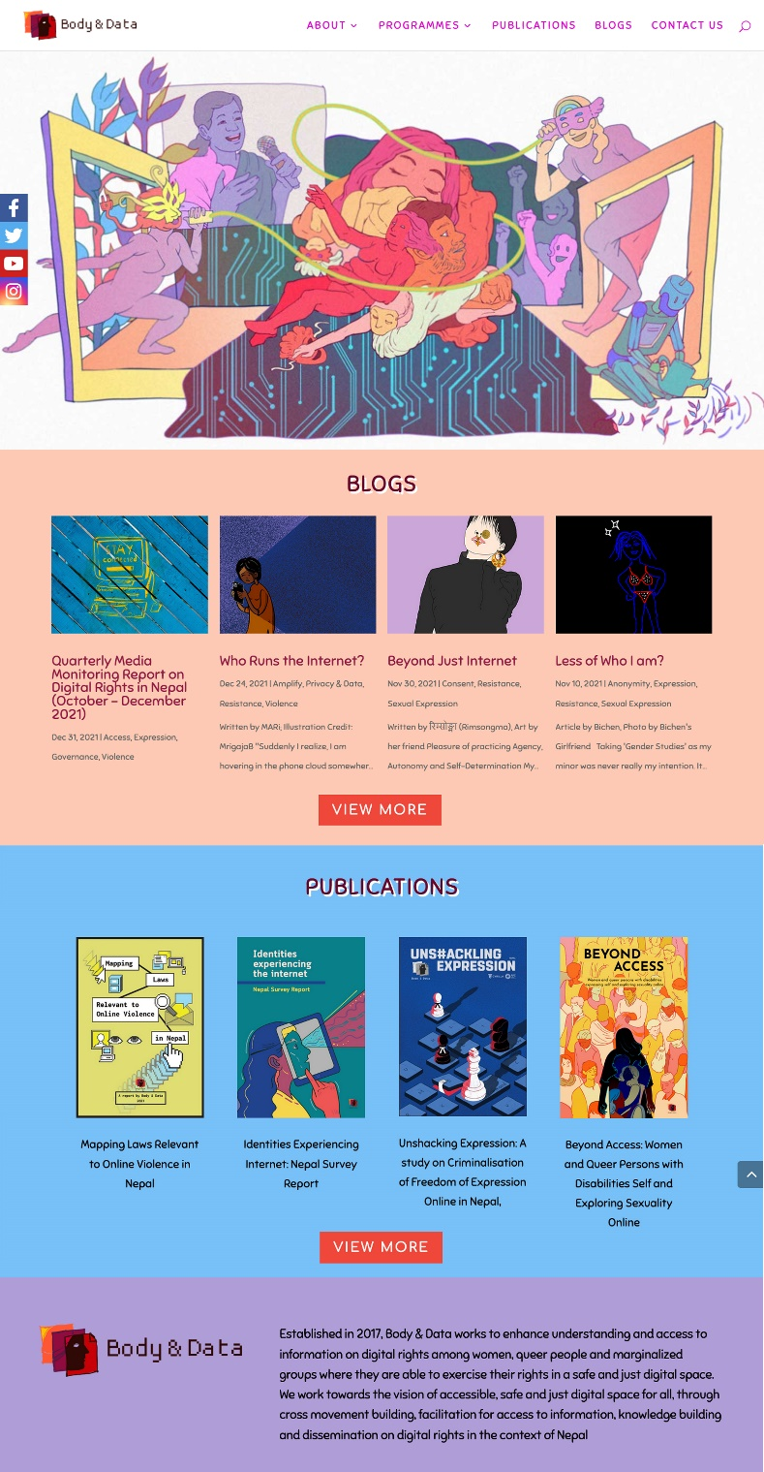

Publications
Kayastha, S., Baramu, R., (2021). Mapping Laws Related to Online Gender Based Violence in Nepal. Retrieved from Body & Data: https://bodyanddata.org/mapping-laws-relevant-to-online-violence-in-nepal/
Body & Data. (2020). NETIZENS: Survey on Internet Usage among Urban Young People in Nepal. Body & Data. Retrieved from Body & Data: https://bodyanddata.org/netizens-survey-on-internet-usage-among-urban-young-people-in-nepal/
Kayastha, S., Pokharel, M., (2020). Beyond access: Women and queer persons with disabilities expressing self and exploring sexuality online. Body & Data. Retrived from Body & Data: https://bodyanddata.org/beyond-access-english/
Kayastha, S., Pokharel, M., (2020).Identities Experiencing the Internet: Nepal Survey Report. Body & Data. Retrived from Body & Data: https://bodyanddata.org/identities-experiencing-internet-nepal-survey-report/
Body & Data. (2021, Aug 3). Quarterly Media Monitoring Report on Digital Rights in Nepal (April – June 2021). Body & Data. Retrieved from Body & Data: https://bodyanddata.org/quarterly-media-monitoring-report-on-digital-rights-in-nepal-april-june-2021/
Body & Data. (2021, Oct 6). Quarterly Media Monitoring Report on Digital Rights in Nepal (July – September 2021). Body & Data. Retrieved from Body & Data: https://bodyanddata.org/quarterly-media-monitoring-report-on-digital-rights-in-nepal-july-september-2021/
Body & Data. (2021, Dec 31). Quarterly Media Monitoring Report on Digital Rights in Nepal (October – December 2021)). Body & Data. Retrieved from Body & Data: https://bodyanddata.org/quarterly-media-monitoring-report-on-digital-rights-in-nepal-october-december-2021/

Media
#36 Guff Gaff with Shubha Kayastha: Smile, Please - Sarkar Is Watching! With Boju Bajai:
Episode 2 - Bodies, Autonomy, and Storytelling with Global Data Justice
Nepal Chautari - Children and Internet with Antenna Foundation Nepal
Episode 10: जातको प्रश्न with Samata Foundation

Articles:

Body & Data. (2021, Jan 29). Privacy Consultation Findings: What Online and Data Privacy Means to Communities. Retrieved from Body & Data: https://bodyanddata.org/privacy-consultation-findings-what-online-and-data-privacy-means-to-communities/
Body & Data. (2021, Mar 26). Social Media Management Directive 2021 and Its Problems. Retrieved from Body & Data: https://bodyanddata.org/social-media-management-directive-2021-and-its-problems/
Body & Data. (2021, Apr 23). #SupportForNikisha. Retrieved from Body & Data: https://bodyanddata.org/supportforniksiha/
बडी एण्ड डाटा (2021, Apr 27). ऐक्यबद्धताका लागि आग्रह. Retrieved from Body & Data: https://bodyanddata.org/ऐक्यबद्धताका लागि आग्रह/
बडी एण्ड डाटा (2021, Oct 1). ४ युटुवर पक्राउ सम्बन्धी घटनाबारे हाम्रो धारणा. Retrieved from Body & Data: https://bodyanddata.org/४ युटुवर पक्राउ सम्बन्धी घटनाबारे हाम्रो धारणा/

Body & Data
bodyanddata.org

Facebook | Instagram | Twitter
@bodyanddata

